

**CS3481 Assignment 3 Study on hierarchical clustering**

**Chan Tsz Fung (56228799)**

Contents

Data Preparation 3

Removing Outliers 3

Normalization 6

(a) Compare the hierarchical structures generated using single link, complete link and group average for the Wine data set. (30%) 7

DISTANCE OVERVIEW 8

DISTANCE – FROM each point of view 9

Size of merge- Overview 15

Merge Size- Looking into each cluster solution 20

(b) For some of these hierarchical structures, observe the set of distance values at which cluster merge occurs, and identify possible patterns from these values. (20%) 32

Single Link 32

Complete Link 36

(c)Select different clustering solutions from the hierarchical structures, and compare the cluster groupings with the corresponding K-means clustering solutions (using the method KMeans from the module sklearn.cluster), in terms of the extent to which the clusters can capture the class structure of the data set. (30%) 39

(d) Select different subsets of attributes from the data sets and re-perform hierarchical clustering. Compare the resulting hierarchical structures based on the selected attribute subsets with the original hierarchical structures. (20%) 46

Preparation 46

Effect on Merge Distance 51

Effect on Merge Size 62

## Data Preparation

We load our **wine dataset** from the scikit learn library. 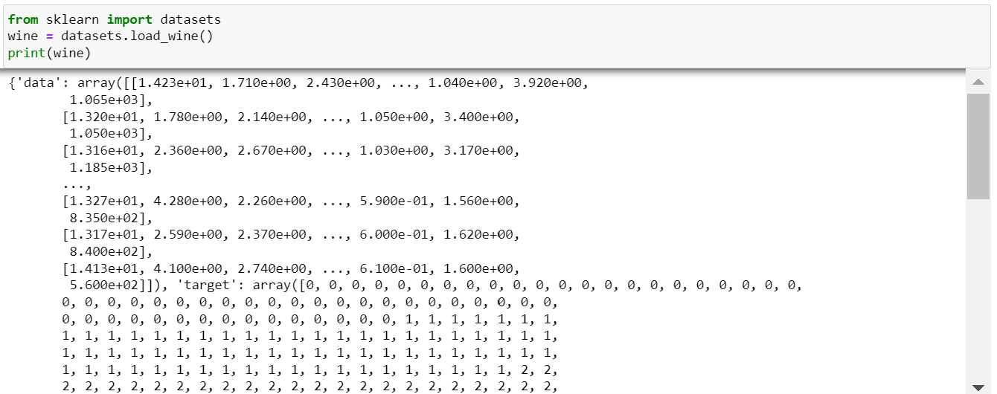

This dataset contains 13 attributes and 1 classification label. There are a total of 178 records. In order to improve clustering results, we have **removed the outliers** and **normalized** the list of values for every attribute.

### Removing Outliers

To detect the outliers, we draw box plot using seaborn library. A point is considered as outliers if its value is smaller than Q1-1.5*IQR or its value is larger than Q3+1.5*IQR. We check every attribute one by one as below:

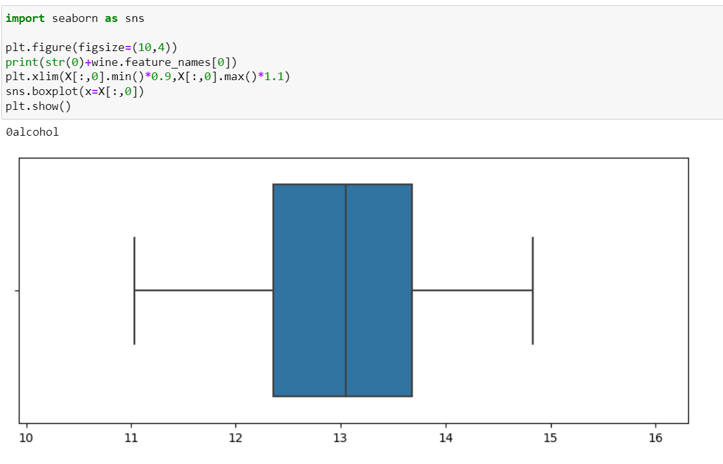

This attribute has no outliers, we would then look for the next attribute.

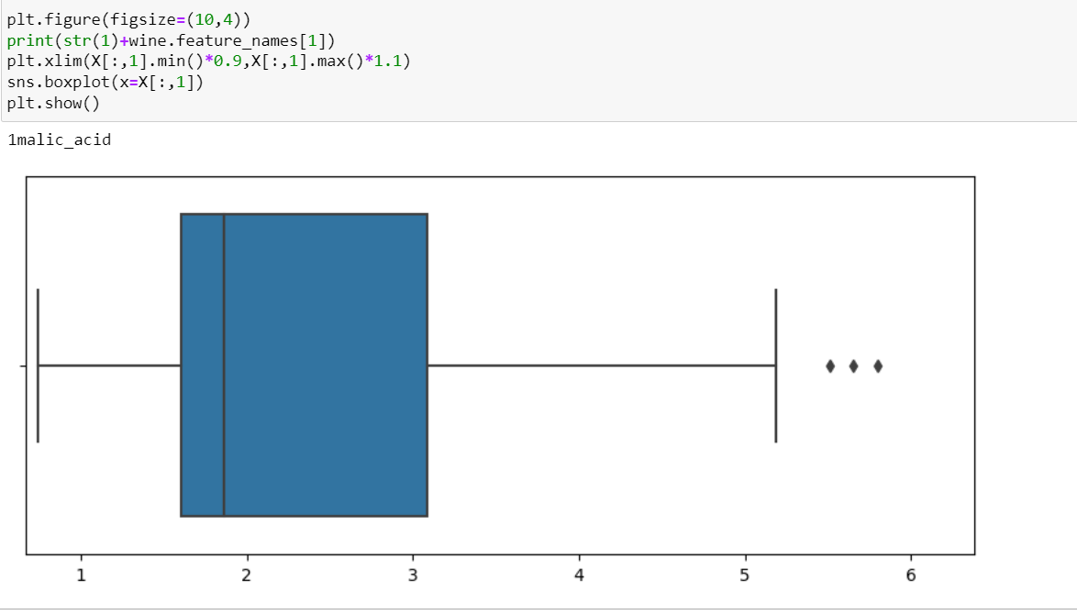

This attribute has three outliers, we would just delete the corresponding three records from the dataset. The number of records became 175.

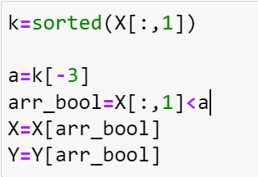

Similar deletion of records are performed based on the outliers of other attributes. The results are shown below:

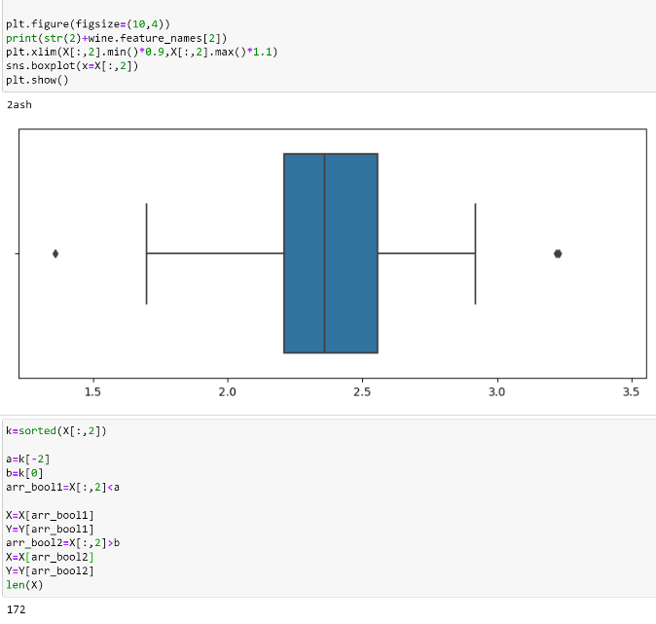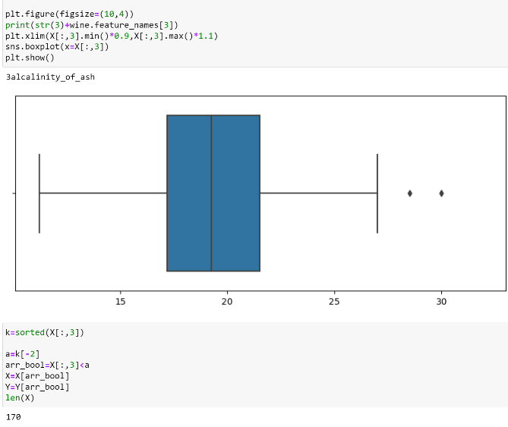

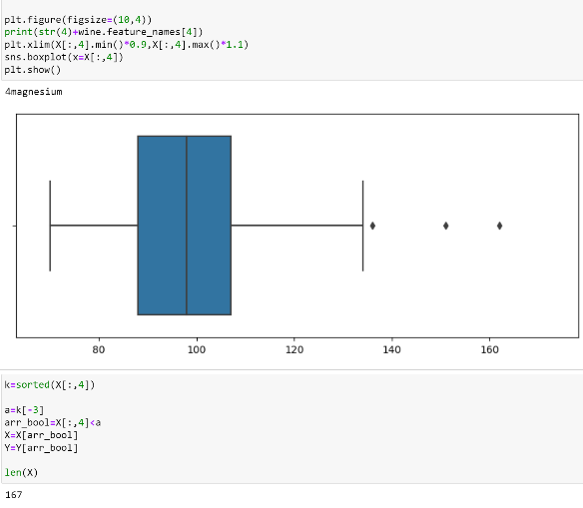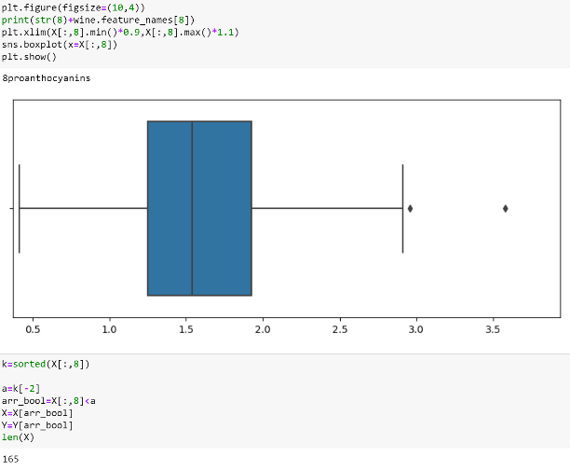

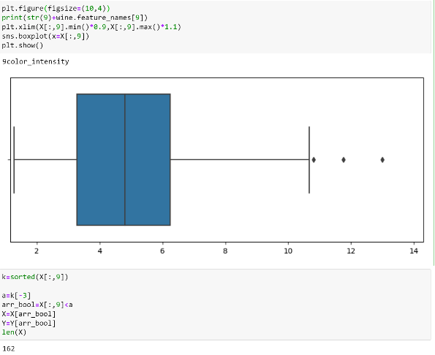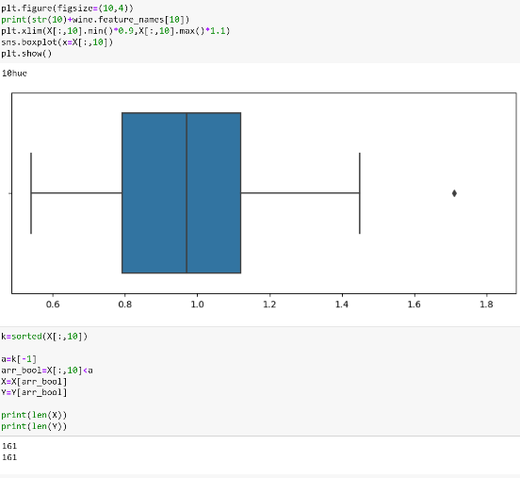

After one round of detection and removal, 161 records remained. We would use these 161 records for performing our clustering task.

### Normalization

Next, we normalize the value in every attribute by using the formula X’= (X-min)/(max-min), where max, min, X, X’ are the maximum value, minimum value, original value, and normalized value for the attribute respectively.

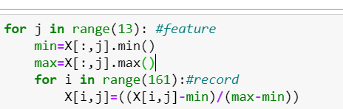

The sample normalized result for the first attribute is shown below: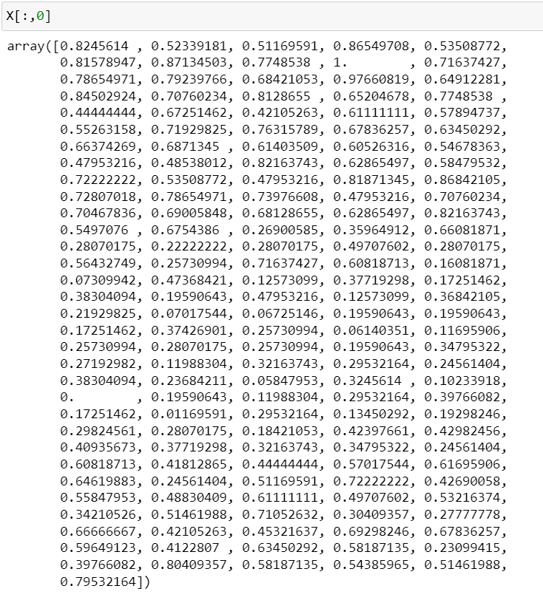

The maximum value is updated as 1 and the minimum value is updated as 0.

After normalization, clustering is performed.

## (a) Compare the hierarchical structures generated using single link, complete link and group average for the Wine data set. (30%)

The three constructed hierarchical structures generated using single link, complete link and group average are shown as follows:

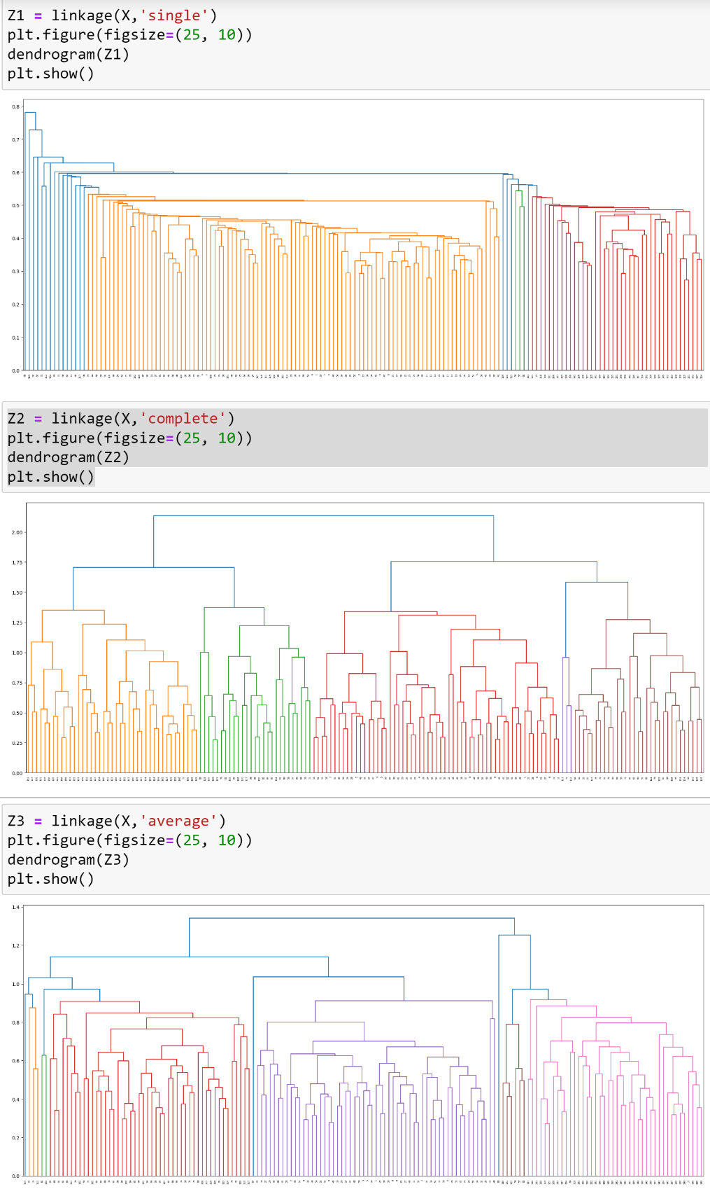

In general, for the preprocessed 161 records, 160 merges (iterations) should be found in Z, which means len (Z)=160. After the i-th merge, the solution should consist of (161-i) clusters.

We would compare and analyze the three hierarchical structures in the following ways, they are:

1. distance between two points/clusters when merged
2. size of clusters when being merged

### DISTANCE OVERVIEW

First, we would look into the trend of distance increase for each of the approaches. We plot all the lists of distances for a clear visualization: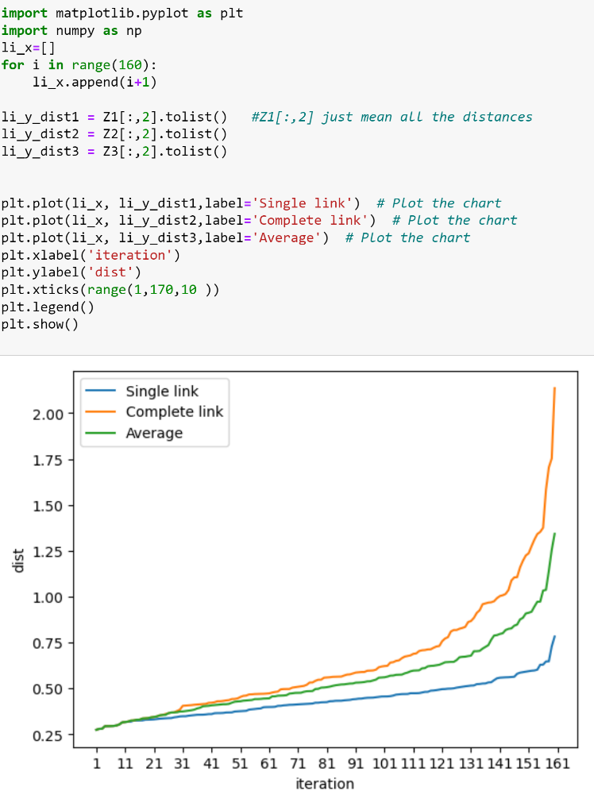

Obviously, we can see that the rate of distance increase is different for every approach. In the first 20 iterations, the rate of distance increase is still very similar. However, the difference in the rate of distance increase starts to appear when the number of iterations gets larger. This is the time when clusters start to merge with points or cluster starts merging with cluster. When this is the case, the complete link method always selects the maximum distance, therefore reaching a much higher rate in distance increase. In opposite, the single link method is selecting the minimum value as inter-cluster distance. It results in a lower rate in distance increase compared to the complete link approach. Regarding the rate of distance increase for average method, it is somewhere between the single link and complete link.

Another thing we can look at is the range of merge distance. It is shown that single link method has the smallest range, the complete link method has the largest range, and average method is somewhere in the middle. This also make sense for the different metrics on selecting the inter-cluster distance. If we use a larger distance for inter-cluster distance, the distance we used for merging in the later iterations would increase.

### DISTANCE – FROM each point of view

In the following, we would try to find out the merge distance for every record under Single Link, Complete Link and Group Average. We write the result to a csv file.

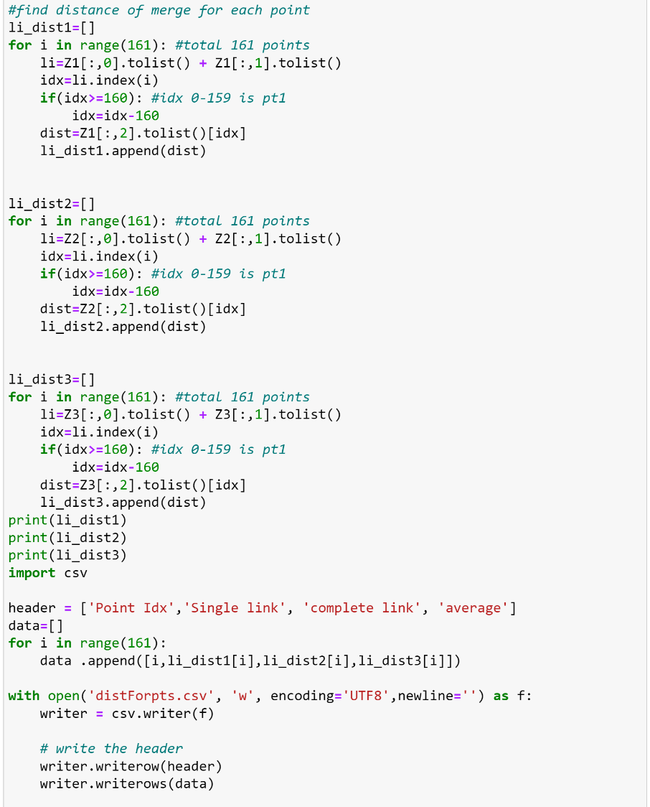

The file result is displayed below:

For every point, we rank the 3 distance value, largest distance among the three would be highlighted in red, second largest would be highlighted in green, and the smallest distance would be highlighted in blue. If there are two largest distances, both distance would be highlighted as red and the remaining one would be highlighted as blue. Furthermore, we would not do any highlighting if 3 distances are equal.

|  |  |  |  |
| --- | --- | --- | --- |
| Point Idx | Single link | complete link | average |
| 0 | 0.293638386 | 0.293638386 | 0.293638386 |
| 1 | 0.431889329 | 0.512728315 | 0.472308822 |
| 2 | 0.455366431 | 0.469060038 | 0.462213234 |
| 3 | 0.414047321 | 0.452478212 | 0.443521691 |
| 4 | 0.459963508 | 0.459963508 | 0.459963508 |
| 5 | 0.368291762 | 0.368291762 | 0.368291762 |
| 6 | 0.329016437 | 0.430799256 | 0.379907847 |
| 7 | 0.429477466 | 0.56328036 | 0.53043768 |
| 8 | 0.436423905 | 0.479742198 | 0.516080491 |
| 9 | 0.278463057 | 0.278463057 | 0.278463057 |
| 10 | 0.363716073 | 0.363716073 | 0.363716073 |
| 11 | 0.278890796 | 0.278890796 | 0.278890796 |
| 12 | 0.278890796 | 0.278890796 | 0.278890796 |
| 13 | 0.584850611 | 0.817418732 | 0.817418732 |
| 14 | 0.293148928 | 0.293148928 | 0.293148928 |
| 15 | 0.302857244 | 0.302857244 | 0.302857244 |
| 16 | 0.302857244 | 0.302857244 | 0.302857244 |
| 17 | 0.384752728 | 0.441650285 | 0.441650285 |
| 18 | 0.420984344 | 0.420984344 | 0.420984344 |
| 19 | 0.293638386 | 0.293638386 | 0.293638386 |
| 20 | 0.489661739 | 0.596115863 | 0.581179006 |
| 21 | 0.328066383 | 0.328066383 | 0.328066383 |
| 22 | 0.313926332 | 0.313926332 | 0.313926332 |
| 23 | 0.313926332 | 0.313926332 | 0.313926332 |
| 24 | 0.334958099 | 0.334958099 | 0.334958099 |
| 25 | 0.324500236 | 0.324500236 | 0.324500236 |
| 26 | 0.431574291 | 0.459963508 | 0.459963508 |
| 27 | 0.328066383 | 0.328066383 | 0.328066383 |
| 28 | 0.45488062 | 0.495998433 | 0.475340661 |
| 29 | 0.363716073 | 0.363716073 | 0.363716073 |
| 30 | 0.447870802 | 0.563548486 | 0.537813367 |
| 31 | 0.446090461 | 0.56328036 | 0.512744115 |
| 32 | 0.294320022 | 0.294320022 | 0.294320022 |
| 33 | 0.330118732 | 0.407872396 | 0.368995564 |
| 34 | 0.359078142 | 0.420336286 | 0.389707214 |
| 35 | 0.294320022 | 0.294320022 | 0.294320022 |
| 36 | 0.324500236 | 0.324500236 | 0.324500236 |
| 37 | 0.420984344 | 0.420984344 | 0.420984344 |
| 38 | 0.315669516 | 0.315669516 | 0.315669516 |
| 39 | 0.404285071 | 0.404285071 | 0.404285071 |
| 40 | 0.411095372 | 0.411095372 | 0.411095372 |
| 41 | 0.404285071 | 0.404285071 | 0.404285071 |
| 42 | 0.355750594 | 0.423565197 | 0.412703503 |
| 43 | 0.510497925 | 0.540378925 | 0.525438425 |
| 44 | 0.53159928 | 0.588569214 | 0.57434218 |
| 45 | 0.278463057 | 0.278463057 | 0.278463057 |
| 46 | 0.406701089 | 0.406701089 | 0.406701089 |
| 47 | 0.398826187 | 0.441650285 | 0.441650285 |
| 48 | 0.601001281 | 0.817418732 | 0.817418732 |
| 49 | 0.372886263 | 0.495542221 | 0.427952428 |
| 50 | 0.368291762 | 0.368291762 | 0.368291762 |
| 51 | 0.293148928 | 0.293148928 | 0.293148928 |
| 52 | 0.332036236 | 0.423565197 | 0.426263079 |
| 53 | 0.406701089 | 0.406701089 | 0.406701089 |
| 54 | 0.315669516 | 0.315669516 | 0.315669516 |
| 55 | 0.333912061 | 0.334958099 | 0.334958099 |
| 56 | 0.411095372 | 0.411095372 | 0.411095372 |
| 57 | 0.495745757 | 0.495745757 | 0.495745757 |
| 58 | 0.5440353 | 0.575583317 | 0.559809308 |
| 59 | 0.505689287 | 0.505689287 | 0.505689287 |
| 60 | 0.341173739 | 0.341173739 | 0.341173739 |
| 61 | 0.466809581 | 0.466809581 | 0.628093796 |
| 62 | 0.497574237 | 0.563548486 | 0.715923012 |
| 63 | 0.587755066 | 0.622201928 | 0.609823103 |
| 64 | 0.364561958 | 0.518566268 | 0.435973342 |
| 65 | 0.495745757 | 0.495745757 | 0.495745757 |
| 66 | 0.591157357 | 0.706896178 | 0.643609769 |
| 67 | 0.646080789 | 1.00693017 | 1.036194381 |
| 68 | 0.526131518 | 0.778284502 | 0.641654177 |
| 69 | 0.560022332 | 0.702993137 | 0.675237812 |
| 70 | 0.532658516 | 0.596943001 | 0.596943001 |
| 71 | 0.487612863 | 0.505689287 | 0.505689287 |
| 72 | 0.596943001 | 0.596943001 | 0.596943001 |
| 73 | 0.55746423 | 0.55746423 | 0.55746423 |
| 74 | 0.37551805 | 0.37551805 | 0.37551805 |
| 75 | 0.396360832 | 0.43353554 | 0.43353554 |
| 76 | 0.346273066 | 0.346273066 | 0.346273066 |
| 77 | 0.523078404 | 0.569483041 | 0.542288323 |
| 78 | 0.43514818 | 0.43514818 | 0.43514818 |
| 79 | 0.423047785 | 0.43353554 | 0.43353554 |
| 80 | 0.364457095 | 0.466809581 | 0.440818564 |
| 81 | 0.346273066 | 0.346273066 | 0.346273066 |
| 82 | 0.355360983 | 0.412803968 | 0.44075908 |
| 83 | 0.397928297 | 0.46935223 | 0.44075908 |
| 84 | 0.324608083 | 0.337331489 | 0.337331489 |
| 85 | 0.337331489 | 0.337331489 | 0.337331489 |
| 86 | 0.296856552 | 0.296856552 | 0.296856552 |
| 87 | 0.472701616 | 0.508594786 | 0.508594786 |
| 88 | 0.508594786 | 0.508594786 | 0.508594786 |
| 89 | 0.781616995 | 1.002492122 | 1.254227677 |
| 90 | 0.37551805 | 0.37551805 | 0.37551805 |
| 91 | 0.341173739 | 0.341173739 | 0.341173739 |
| 92 | 0.646559074 | 0.96863077 | 0.875046619 |
| 93 | 0.468733322 | 0.54636563 | 0.537357199 |
| 94 | 0.42095524 | 0.471979422 | 0.459194523 |
| 95 | 0.376905088 | 0.428840997 | 0.402873043 |
| 96 | 0.423681717 | 0.428939594 | 0.428939594 |
| 97 | 0.32381391 | 0.32381391 | 0.32381391 |
| 98 | 0.554218986 | 0.639922984 | 0.597656771 |
| 99 | 0.350170116 | 0.3592306 | 0.354700358 |
| 100 | 0.296856552 | 0.296856552 | 0.296856552 |
| 101 | 0.428939594 | 0.428939594 | 0.428939594 |
| 102 | 0.43514818 | 0.43514818 | 0.43514818 |
| 103 | 0.352015568 | 0.352015568 | 0.352015568 |
| 104 | 0.628093796 | 0.77106967 | 0.628093796 |
| 105 | 0.473413135 | 0.601039687 | 0.54691227 |
| 106 | 0.397568697 | 0.46935223 | 0.460498161 |
| 107 | 0.32381391 | 0.32381391 | 0.32381391 |
| 108 | 0.439523156 | 0.559895037 | 0.563226579 |
| 109 | 0.593027614 | 0.689881017 | 0.725341192 |
| 110 | 0.514463199 | 0.558672715 | 0.558672715 |
| 111 | 0.433949861 | 0.587070262 | 0.532053613 |
| 112 | 0.55746423 | 0.55746423 | 0.55746423 |
| 113 | 0.72825923 | 0.957912869 | 0.945570442 |
| 114 | 0.352015568 | 0.352015568 | 0.352015568 |
| 115 | 0.412792634 | 0.44437035 | 0.44437035 |
| 116 | 0.443063824 | 0.44437035 | 0.44437035 |
| 117 | 0.558672715 | 0.558672715 | 0.558672715 |
| 118 | 0.52220491 | 0.642053703 | 0.643609769 |
| 119 | 0.273295224 | 0.273295224 | 0.273295224 |
| 120 | 0.336941448 | 0.466205163 | 0.401573305 |
| 121 | 0.273295224 | 0.273295224 | 0.273295224 |
| 122 | 0.412970137 | 0.412970137 | 0.412970137 |
| 123 | 0.412970137 | 0.412970137 | 0.412970137 |
| 124 | 0.578921456 | 0.687650401 | 0.669036924 |
| 125 | 0.354397131 | 0.354397131 | 0.354397131 |
| 126 | 0.328397087 | 0.328397087 | 0.328397087 |
| 127 | 0.318182818 | 0.318182818 | 0.318182818 |
| 128 | 0.480391785 | 0.494011322 | 0.518314711 |
| 129 | 0.318182818 | 0.318182818 | 0.318182818 |
| 130 | 0.472662934 | 0.476486836 | 0.474574885 |
| 131 | 0.499440412 | 0.531164701 | 0.530915159 |
| 132 | 0.35530186 | 0.580541025 | 0.444846087 |
| 133 | 0.525568998 | 0.809113558 | 0.88400766 |
| 134 | 0.367586148 | 0.367586148 | 0.367586148 |
| 135 | 0.343273348 | 0.343273348 | 0.343273348 |
| 136 | 0.414709712 | 0.414709712 | 0.414709712 |
| 137 | 0.45334023 | 0.503113653 | 0.503113653 |
| 138 | 0.503113653 | 0.503113653 | 0.503113653 |
| 139 | 0.46834416 | 0.46834416 | 0.496724753 |
| 140 | 0.456740098 | 0.510367462 | 0.48355378 |
| 141 | 0.480142254 | 0.562042803 | 0.521092528 |
| 142 | 0.347265836 | 0.46834416 | 0.408298875 |
| 143 | 0.559523471 | 0.672478221 | 0.734909262 |
| 144 | 0.367586148 | 0.367586148 | 0.367586148 |
| 145 | 0.386763638 | 0.471005535 | 0.432162346 |
| 146 | 0.323746613 | 0.328397087 | 0.328397087 |
| 147 | 0.33594554 | 0.33594554 | 0.33594554 |
| 148 | 0.292950127 | 0.292950127 | 0.292950127 |
| 149 | 0.354397131 | 0.354397131 | 0.354397131 |
| 150 | 0.409859768 | 0.409859768 | 0.409859768 |
| 151 | 0.368015895 | 0.383355272 | 0.383355272 |
| 152 | 0.409859768 | 0.409859768 | 0.409859768 |
| 153 | 0.562499269 | 0.727623053 | 0.62169751 |
| 154 | 0.33594554 | 0.33594554 | 0.33594554 |
| 155 | 0.383355272 | 0.383355272 | 0.383355272 |
| 156 | 0.292950127 | 0.292950127 | 0.292950127 |
| 157 | 0.343273348 | 0.343273348 | 0.343273348 |
| 158 | 0.414709712 | 0.414709712 | 0.414709712 |
| 159 | 0.448295657 | 0.574431593 | 0.496724753 |
| 160 | 0.497996659 | 0.531290806 | 0.573069838 |
| AVG | 0.415976 | 0.46007 | 0.454181 |
| MAX | 0.781617 | 1.00693 | 1.254228 |
| MIN | 0.273295 | 0.273295 | 0.273295 |
| RANGE | 0.508322 | 0.733635 | 0.980932 |

After highlighting, we have noticed serval patterns in the resulted merge distance when using different approaches in calculating inter-cluster distance. Most of the distance for single linked tends to be blue. It means that for each of the records, **the merging distance using single link tends to be smaller compared to those distances using complete link and group average**. The same conclusion can also be drawn from average merging distance, MAX merging distance and RANGE of merging distance (which is the last 4 row in the table).

On the other hand, majority of the distances using complete link is highlighted as red. There are 64 records (out of 161 records) highlighted as red in complete link, while there are only 33 records highlighted as red in group average. It means that over the 3 different approaches in calculating the inter-cluster distance, **complete link tends to give the largest distance for each of the merge**. The same conclusion can also be drawn from the average of the merging distances. (The average merge distance for complete link is 0.46 while the average merge distance for group average is about 0.45.)

Similarly, most of the **merge distance of records using group average sits between the distance using Single link and complete link.** Their values are highlighted as green in the table. The average merge distance for group average also shows this pattern.

However, the largest merge distance from the table belongs to group average method, instead of complete link method. The reason behind is that we are just displaying the merge distance for single point data (with index 0 – 160) in table, instead of any cluster-and-cluster merging. The distance for cluster-cluster merging cannot be effectively compared as the clusters being merged are just different for different methods starting from index larger than 160. As a result, the max distance and range of distance displayed in this table is different from the overview result drawn from the broken line graph in the last section. In other words, it means that if we consider all the merging including cluster-cluster merging, the MAX distance and the largest range of distance should lie in the Compete link approach. The distance constructed by complete link is generally larger if we consider the full picture, just like the average distance represented for point merges in the table.

After talking about the average distance and max distance, min distances are the same among the three hierarchical structures. They all have the same starting point. This is because they all sharing the same smallest distance when doing their first merge, which is merging point 119 and point 121:

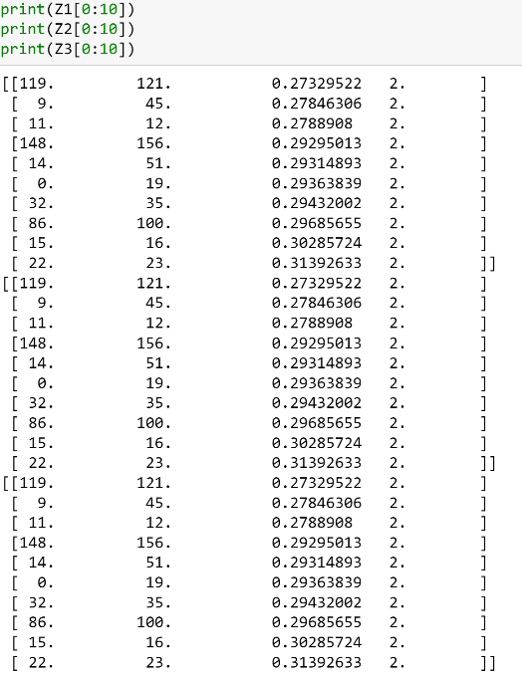

In the next section, we will compare the merge size of the 3 structures.

### Size of merge- Overview

To cluster 161 records, there are always 160 merges need to be done, no matter which metrics we use for calculating inter-cluster distance. After any merge step i, the number of clusters being formed would be (161-i) clusters. After 160 iterations, all the records would converge into one cluster.

We first illustrate the size of cluster being formed in each iteration and plot all of them onto a plot:

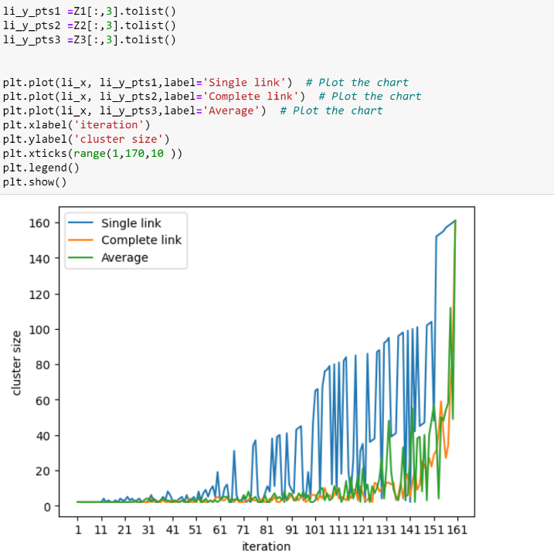

We can see that the merge size of the cluster formed in Single Link fluatate most. It means that a relatively larger cluster is often merge with small clusters **throughout all the iterations**. This make sense as single link always choose smallest value when calculating intercluster distance. As a result, cluster merging **would occur earlier** compared to the other two methods. This can be represented by the peaks of the blue line in the graph starting from iteration 60. At that point, Complete link and group average are still quite stable. It means that the point and point / small cluster to small cluster merging are still occuring continuosly. There are not much difference in the size of the two merging size. There will be no large cluster merging with small cluster at that point.

The peaks of the green line start appearing about iteration 115. It means that at this point, larger cluster starts to merge with some smaller cluster. For complete link, the peak (larger cluster merge with smaller cluster) starts even later. It only occurs at the last part of the 160 iterations (about iteration 125).

Other than the timing of the peaks occurs, the size of the peaks are also different for the three methods. Single link tends to give much larger peaks compared to the other two methods. It means that during the process of merging, Single link continously to merge small cluster with small cluster. But whenever there exist cluster to point distance lower than the point to point distance, the point would be merged into the cluster. This is a frequent case for single link as we always choose the smallest value for claculating intercluster distance. As a result, a larger size cluster are more likely to form in early stage, resulting in a big peak in Single link method.

In contrast, the stability of complete link and group average are just the opposite. As we don’t prefer cluster-cluster merging so often, Point to point merging would be much more often in the early iterations. This would form many small clusters throughout the process, instead of one large cluster like single link does. Those many clusters would only merge with each other when all the point to pont/ point to cluster merging have been finished, resulting a realtively stable line in most iteration, and big peaks only occur in late iterations (which represents merging of those clusters).

Meanwhile, group average is somewhere between the two methods. The merging between large cluster and small cluster would not occur too early or too late. The size of the peak would also in the middle between the one produced by the two methods. It means that we would not accumulate points into one large cluster like single link does, we would also not produce large number of small clusters like complete link does. The point to cluster or cluster to cluster merging just make the point more likely to be distributed evenly to all the clusters formed, in a smoother pace.

Other than the plot illustrated above, I have also prepared three additional plot for showing the same conclusion. The only difference is that we show the size of cluster A and size of cluster B separately into two lines. These 3 plots share the same obserbvation compared with the previous plot.

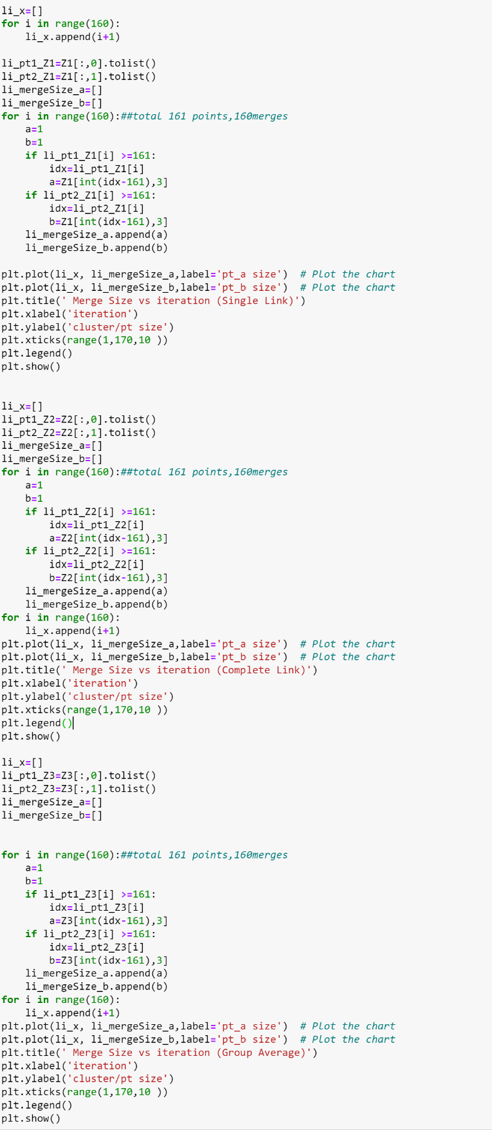

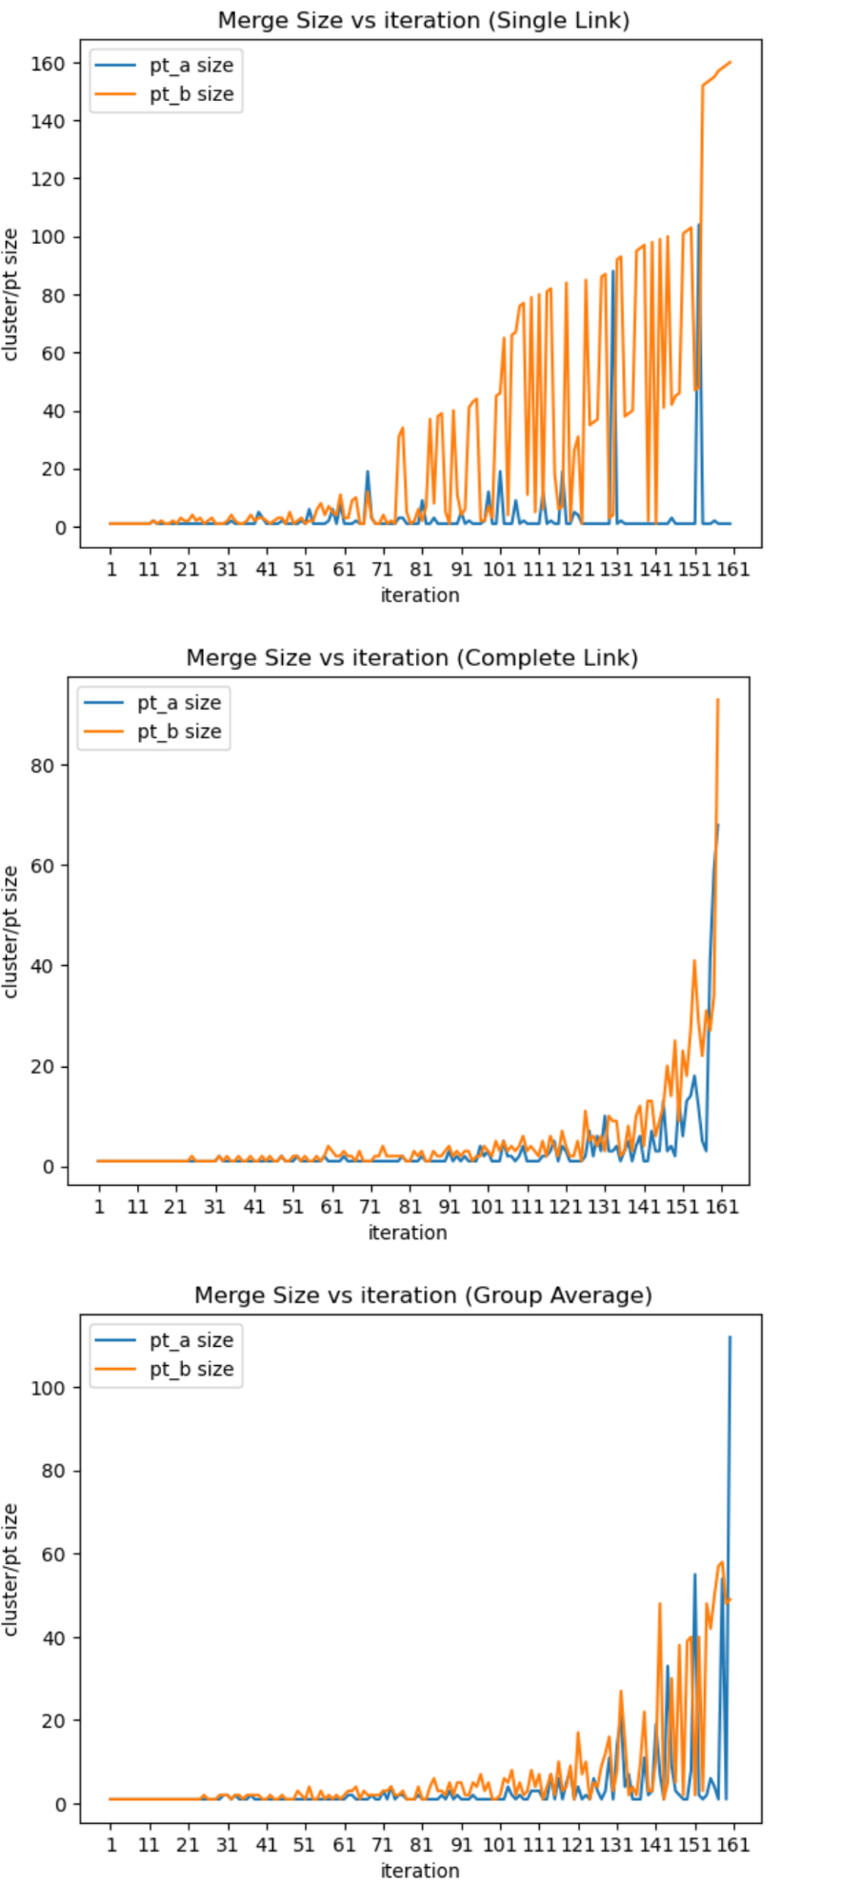

### Merge Size- Looking into each cluster solution

In the following, we would look into each cluster solution in detail for supporting the argument we have stated previously.

We would use the following code for analyzing the merge size of the corresponding two clusters in each merge step.

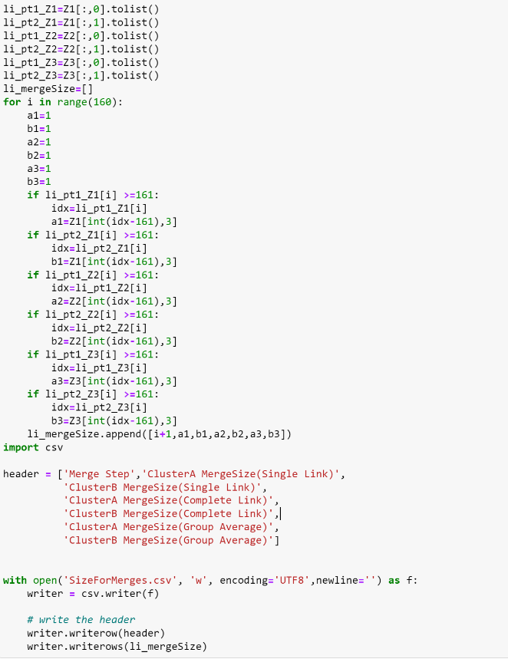

The results are written in csv and shown as below:

Since we have 161 points, Lets define cluster size X as follows:

If X<10, small cluster

If 50>X>=10, medium cluster

If X>=50, large cluster

We would highlight the size with Red, Green and Blue according to the size.

|  |  |  |  |  |  |  |
| --- | --- | --- | --- | --- | --- | --- |
| Merge Step | ClusterA MergeSize(Single Link) | ClusterB MergeSize(Single Link) | ClusterA MergeSize(Complete Link) | ClusterB MergeSize(Complete Link) | ClusterA MergeSize(Group Average) | ClusterB MergeSize(Group Average) |
| 1 | 1 | 1 | 1 | 1 | 1 | 1 |
| 2 | 1 | 1 | 1 | 1 | 1 | 1 |
| 3 | 1 | 1 | 1 | 1 | 1 | 1 |
| 4 | 1 | 1 | 1 | 1 | 1 | 1 |
| 5 | 1 | 1 | 1 | 1 | 1 | 1 |
| 6 | 1 | 1 | 1 | 1 | 1 | 1 |
| 7 | 1 | 1 | 1 | 1 | 1 | 1 |
| 8 | 1 | 1 | 1 | 1 | 1 | 1 |
| 9 | 1 | 1 | 1 | 1 | 1 | 1 |
| 10 | 1 | 1 | 1 | 1 | 1 | 1 |
| 11 | 1 | 1 | 1 | 1 | 1 | 1 |
| 12 | 2 | 2 | 1 | 1 | 1 | 1 |
| 13 | 1 | 1 | 1 | 1 | 1 | 1 |
| 14 | 1 | 2 | 1 | 1 | 1 | 1 |
| 15 | 1 | 1 | 1 | 1 | 1 | 1 |
| 16 | 1 | 1 | 1 | 1 | 1 | 1 |
| 17 | 1 | 2 | 1 | 1 | 1 | 1 |
| 18 | 1 | 1 | 1 | 1 | 1 | 1 |
| 19 | 1 | 3 | 1 | 1 | 1 | 1 |
| 20 | 1 | 2 | 1 | 1 | 1 | 1 |
| 21 | 1 | 2 | 1 | 1 | 1 | 1 |
| 22 | 1 | 4 | 1 | 1 | 1 | 1 |
| 23 | 1 | 2 | 1 | 1 | 1 | 1 |
| 24 | 1 | 3 | 1 | 1 | 1 | 1 |
| 25 | 1 | 1 | 1 | 2 | 1 | 2 |
| 26 | 1 | 2 | 1 | 1 | 1 | 1 |
| 27 | 1 | 3 | 1 | 1 | 1 | 1 |
| 28 | 1 | 1 | 1 | 1 | 1 | 1 |
| 29 | 1 | 1 | 1 | 1 | 1 | 2 |
| 30 | 1 | 1 | 1 | 1 | 2 | 2 |
| 31 | 1 | 2 | 1 | 1 | 2 | 2 |
| 32 | 2 | 4 | 2 | 2 | 1 | 1 |
| 33 | 1 | 2 | 1 | 1 | 2 | 2 |
| 34 | 1 | 1 | 1 | 2 | 1 | 2 |
| 35 | 1 | 1 | 1 | 1 | 1 | 1 |
| 36 | 1 | 2 | 1 | 1 | 1 | 2 |
| 37 | 1 | 4 | 1 | 2 | 2 | 2 |
| 38 | 1 | 2 | 1 | 1 | 1 | 2 |
| 39 | 5 | 3 | 1 | 1 | 1 | 2 |
| 40 | 3 | 3 | 1 | 2 | 1 | 1 |
| 41 | 1 | 2 | 1 | 1 | 1 | 1 |
| 42 | 1 | 1 | 1 | 1 | 1 | 2 |
| 43 | 1 | 2 | 1 | 2 | 1 | 1 |
| 44 | 1 | 3 | 1 | 1 | 1 | 1 |
| 45 | 2 | 3 | 1 | 2 | 1 | 2 |
| 46 | 1 | 1 | 1 | 1 | 1 | 1 |
| 47 | 1 | 5 | 1 | 1 | 1 | 1 |
| 48 | 1 | 1 | 2 | 2 | 1 | 1 |
| 49 | 1 | 2 | 1 | 1 | 1 | 3 |
| 50 | 2 | 3 | 1 | 1 | 1 | 2 |
| 51 | 1 | 1 | 1 | 2 | 1 | 1 |
| 52 | 6 | 2 | 2 | 2 | 1 | 4 |
| 53 | 1 | 2 | 1 | 1 | 1 | 1 |
| 54 | 1 | 6 | 1 | 2 | 1 | 1 |
| 55 | 1 | 8 | 1 | 1 | 1 | 3 |
| 56 | 1 | 4 | 1 | 1 | 1 | 1 |
| 57 | 2 | 7 | 1 | 2 | 1 | 2 |
| 58 | 6 | 5 | 1 | 1 | 1 | 1 |
| 59 | 1 | 4 | 2 | 2 | 1 | 2 |
| 60 | 8 | 11 | 1 | 4 | 1 | 1 |
| 61 | 1 | 3 | 1 | 3 | 1 | 2 |
| 62 | 1 | 3 | 1 | 2 | 2 | 3 |
| 63 | 1 | 9 | 1 | 2 | 2 | 3 |
| 64 | 2 | 10 | 2 | 3 | 1 | 4 |
| 65 | 1 | 1 | 1 | 2 | 1 | 1 |
| 66 | 1 | 1 | 1 | 2 | 1 | 3 |
| 67 | 19 | 12 | 1 | 1 | 1 | 2 |
| 68 | 3 | 3 | 1 | 3 | 2 | 2 |
| 69 | 1 | 1 | 1 | 1 | 1 | 2 |
| 70 | 1 | 1 | 1 | 1 | 1 | 2 |
| 71 | 1 | 4 | 1 | 1 | 3 | 3 |
| 72 | 1 | 1 | 1 | 2 | 1 | 3 |
| 73 | 1 | 2 | 1 | 2 | 4 | 4 |
| 74 | 1 | 1 | 1 | 4 | 1 | 2 |
| 75 | 3 | 31 | 1 | 2 | 2 | 2 |
| 76 | 3 | 34 | 1 | 2 | 2 | 3 |
| 77 | 1 | 5 | 1 | 2 | 1 | 1 |
| 78 | 1 | 1 | 1 | 2 | 1 | 1 |
| 79 | 1 | 2 | 2 | 2 | 1 | 1 |
| 80 | 1 | 6 | 1 | 1 | 2 | 4 |
| 81 | 9 | 2 | 1 | 1 | 1 | 1 |
| 82 | 1 | 7 | 1 | 3 | 1 | 1 |
| 83 | 1 | 37 | 1 | 2 | 1 | 4 |
| 84 | 3 | 8 | 2 | 3 | 1 | 6 |
| 85 | 1 | 38 | 1 | 1 | 1 | 3 |
| 86 | 1 | 39 | 1 | 1 | 2 | 3 |
| 87 | 1 | 5 | 1 | 3 | 1 | 2 |
| 88 | 1 | 1 | 1 | 2 | 3 | 5 |
| 89 | 1 | 40 | 1 | 2 | 1 | 2 |
| 90 | 1 | 11 | 1 | 3 | 2 | 5 |
| 91 | 5 | 4 | 3 | 4 | 1 | 5 |
| 92 | 1 | 6 | 1 | 2 | 1 | 2 |
| 93 | 2 | 41 | 2 | 3 | 1 | 2 |
| 94 | 1 | 43 | 1 | 2 | 2 | 5 |
| 95 | 1 | 44 | 2 | 3 | 1 | 4 |
| 96 | 1 | 2 | 1 | 3 | 1 | 7 |
| 97 | 2 | 2 | 1 | 1 | 1 | 3 |
| 98 | 12 | 7 | 1 | 2 | 1 | 5 |
| 99 | 1 | 3 | 4 | 2 | 1 | 1 |
| 100 | 1 | 45 | 2 | 4 | 1 | 1 |
| 101 | 19 | 46 | 3 | 3 | 1 | 2 |
| 102 | 1 | 65 | 1 | 2 | 1 | 6 |
| 103 | 1 | 4 | 1 | 5 | 4 | 5 |
| 104 | 1 | 66 | 1 | 3 | 2 | 8 |
| 105 | 9 | 67 | 5 | 5 | 1 | 2 |
| 106 | 1 | 76 | 2 | 3 | 2 | 5 |
| 107 | 2 | 77 | 2 | 4 | 1 | 2 |
| 108 | 1 | 11 | 1 | 3 | 1 | 3 |
| 109 | 1 | 79 | 2 | 4 | 3 | 8 |
| 110 | 1 | 5 | 4 | 6 | 3 | 4 |
| 111 | 1 | 80 | 1 | 3 | 3 | 7 |
| 112 | 12 | 6 | 1 | 4 | 1 | 1 |
| 113 | 1 | 81 | 1 | 3 | 1 | 4 |
| 114 | 2 | 82 | 1 | 2 | 7 | 7 |
| 115 | 1 | 18 | 2 | 5 | 1 | 2 |
| 116 | 1 | 6 | 2 | 2 | 6 | 10 |
| 117 | 19 | 7 | 3 | 6 | 1 | 3 |
| 118 | 1 | 84 | 5 | 4 | 5 | 4 |
| 119 | 1 | 2 | 1 | 2 | 8 | 9 |
| 120 | 5 | 26 | 4 | 7 | 1 | 1 |
| 121 | 4 | 31 | 3 | 4 | 4 | 17 |
| 122 | 1 | 1 | 1 | 2 | 1 | 7 |
| 123 | 1 | 85 | 1 | 2 | 2 | 10 |
| 124 | 1 | 35 | 1 | 5 | 1 | 1 |
| 125 | 1 | 36 | 1 | 1 | 6 | 5 |
| 126 | 1 | 37 | 2 | 11 | 3 | 4 |
| 127 | 1 | 86 | 7 | 5 | 1 | 9 |
| 128 | 1 | 87 | 2 | 6 | 3 | 12 |
| 129 | 1 | 3 | 6 | 4 | 11 | 16 |
| 130 | 88 | 4 | 3 | 6 | 1 | 3 |
| 131 | 1 | 92 | 10 | 3 | 14 | 8 |
| 132 | 2 | 93 | 3 | 10 | 21 | 27 |
| 133 | 1 | 38 | 3 | 9 | 4 | 15 |
| 134 | 1 | 39 | 4 | 9 | 7 | 2 |
| 135 | 1 | 40 | 1 | 2 | 1 | 4 |
| 136 | 1 | 95 | 3 | 3 | 1 | 2 |
| 137 | 1 | 96 | 5 | 8 | 1 | 10 |
| 138 | 1 | 97 | 1 | 3 | 11 | 22 |
| 139 | 1 | 2 | 4 | 10 | 2 | 3 |
| 140 | 1 | 98 | 6 | 12 | 3 | 3 |
| 141 | 1 | 1 | 1 | 4 | 19 | 11 |
| 142 | 1 | 99 | 1 | 13 | 7 | 48 |
| 143 | 1 | 41 | 7 | 13 | 1 | 1 |
| 144 | 1 | 100 | 3 | 6 | 33 | 5 |
| 145 | 3 | 42 | 3 | 9 | 9 | 30 |
| 146 | 1 | 45 | 13 | 12 | 3 | 5 |
| 147 | 1 | 46 | 3 | 20 | 2 | 38 |
| 148 | 1 | 101 | 4 | 14 | 1 | 2 |
| 149 | 1 | 102 | 2 | 25 | 1 | 39 |
| 150 | 1 | 103 | 13 | 9 | 8 | 40 |
| 151 | 1 | 47 | 6 | 23 | 55 | 2 |
| 152 | 104 | 48 | 13 | 18 | 2 | 40 |
| 153 | 1 | 152 | 14 | 27 | 1 | 3 |
| 154 | 1 | 153 | 18 | 41 | 2 | 48 |
| 155 | 1 | 154 | 12 | 29 | 6 | 42 |
| 156 | 2 | 155 | 5 | 22 | 4 | 50 |
| 157 | 1 | 157 | 3 | 31 | 1 | 57 |
| 158 | 1 | 158 | 41 | 27 | 54 | 58 |
| 159 | 1 | 159 | 59 | 34 | 1 | 48 |
| 160 | 1 | 160 | 68 | 93 | 112 | 49 |
| # of red | 34 | | 3 | | 6 | |
| # of green | 36 | | 27 | | 26 | |
| # of blue | 250 | | 290 | | 288 | |
| Earliest red | #step102 | | #step159 | | #step151 | |
| Earliest green | #step60 | | #step126 | | #step116 | |
| Earliest blue | #step1 | | #step1 | | #step1 | |

After highlighting all the data, we can support our claims stated in the previous section. From the table, we can see that **medium size cluster and large size cluster appears earlier when using single link approach**. This is because we use a smaller distance in calculating inter-cluster distance. Point-to-cluster merging and cluster-to-cluster merging would be more preferrable over point-to-point merging compared to the other two approaches. This would result in **a larger cluster being formed in earlier iterations**. These large clusters are later merge with the small cluster and single point for the single link approach. As a result, **the cluster formed using single link would be larger in the later iterations.**

In contrast, the Complete link approach is an opposite situation. It does not prefer cluster merging like single link does. Therefore, it would only perform cluster to cluster merging or cluster to point merging in the later iteration. This would result in **many small clusters being formed in earlier iterations**, instead of one large cluster and many small clusters like single link does. This explains why the **number of large size cluster is smaller in Complete link** compared to Single link (3<34). Meanwhile, this also explains why the **number of small and medium size clusters is greater than** that generated by Single links. (290+27>250+36 for medium and small clusters).

To justify this claim, we can also look at the cluster solution in different steps.

We can first look at a larger k in early iteration. We look at step 10, where k is 161-10=151 clusters being formed in this stage.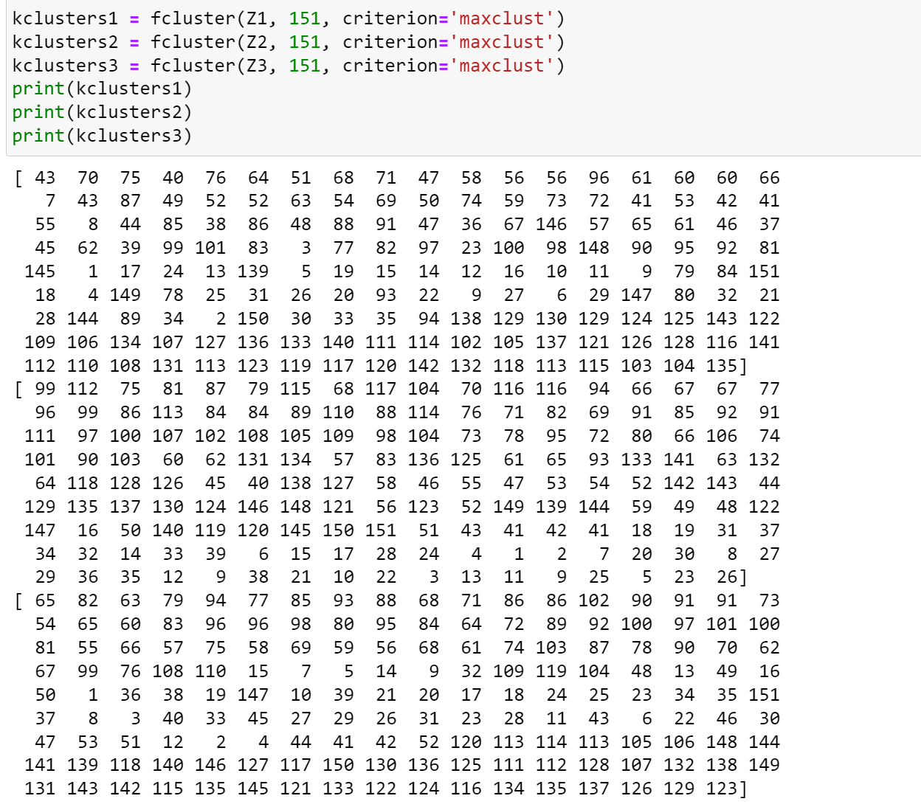

The distribution is extracted in following way:

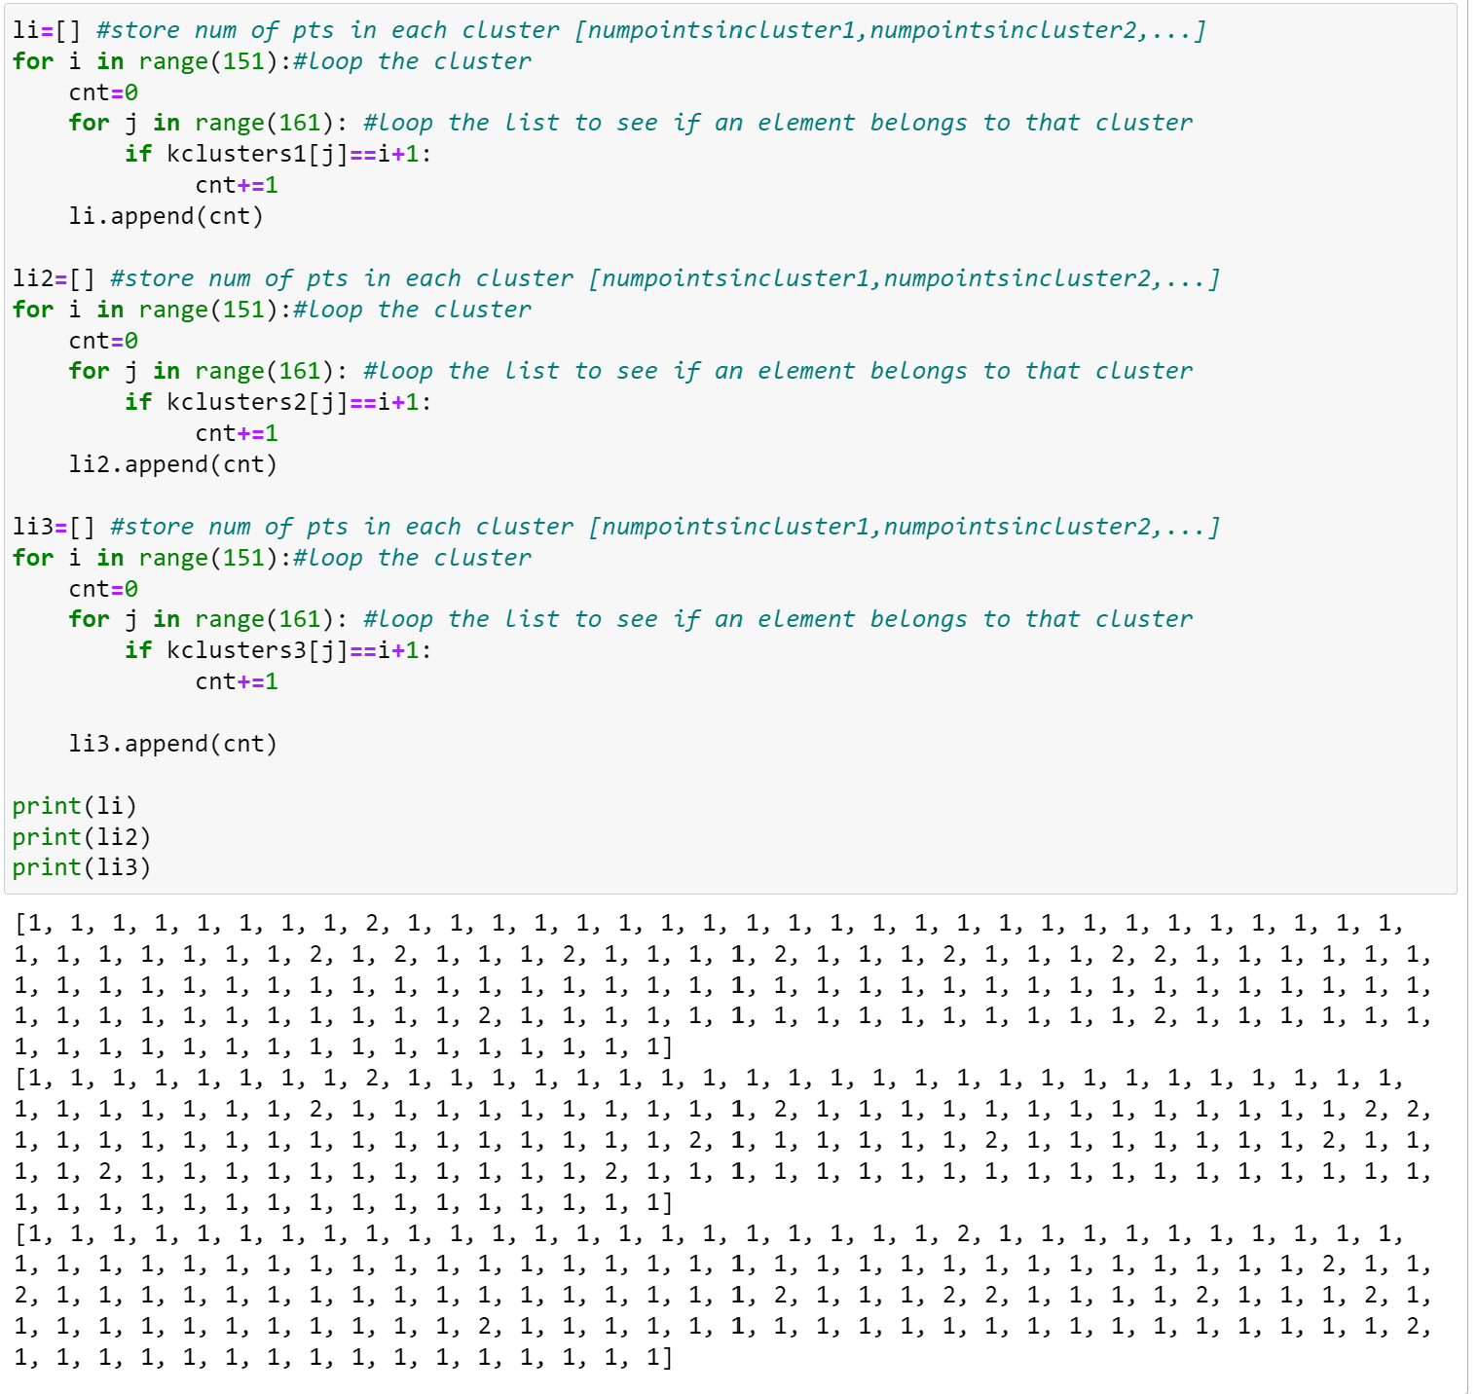

We can then plot the graph:

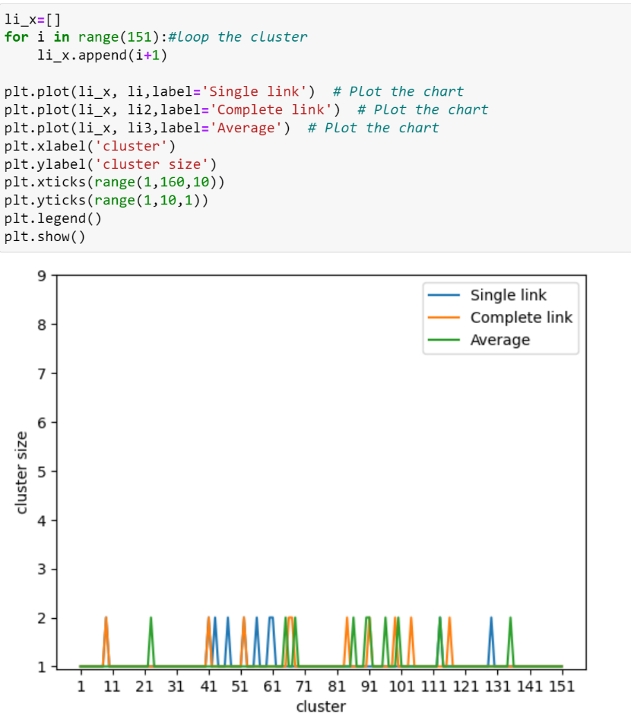

We can see that for each of the clusters, it only consists of one point or two points. No matter which method we use for calculating inter-cluster distance, the distribution of points in different clusters is similar when k is large (early iterations). This is because there are still no point-to-cluster/cluster-to-cluster merging being done at this stage, resulting in no difference by using different methods in calculating inter-cluster distance.

Then we can look at the situation for a smaller k under different approaches. We would take step 102 as an example, which means the number of clusters k=161-102=59.

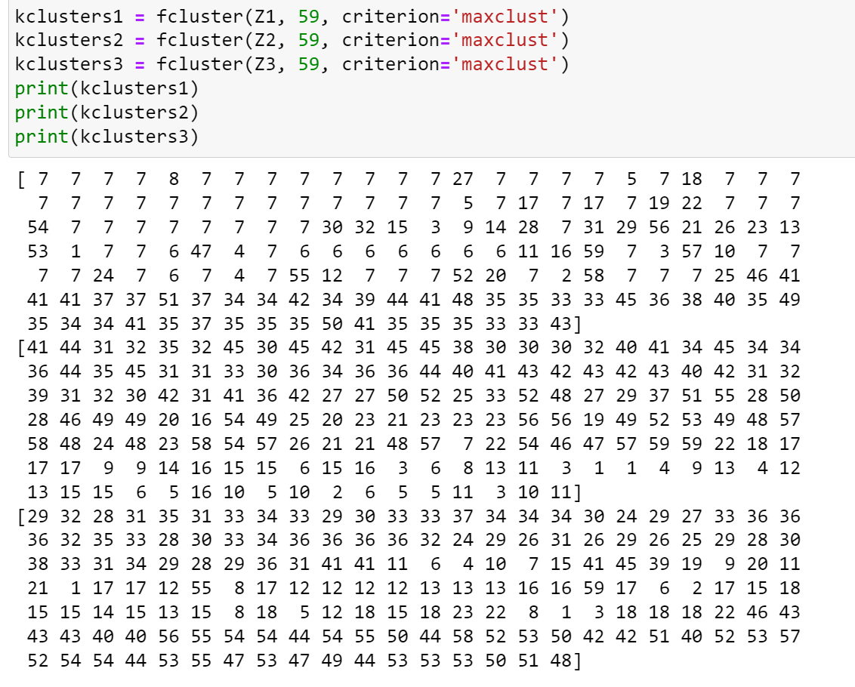

Then we further look at number of points in each cluster:

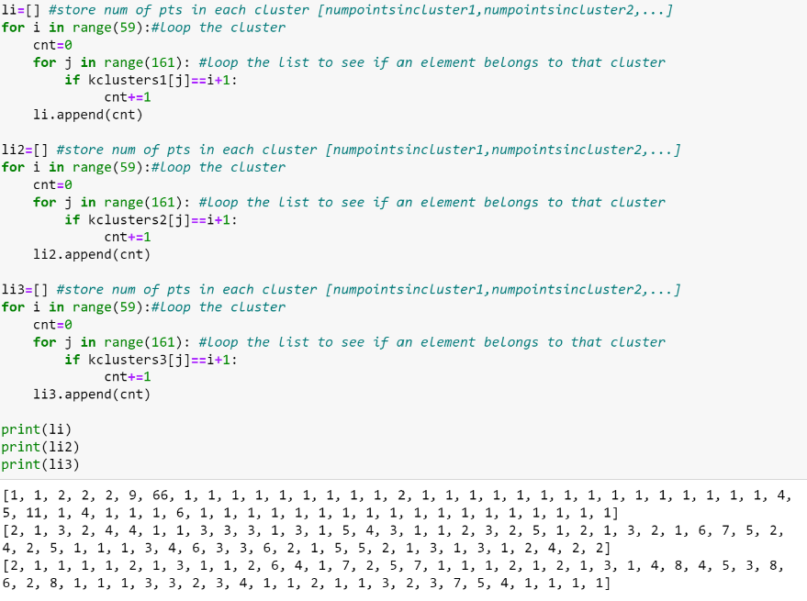

We plot the distribution in broken line graph:

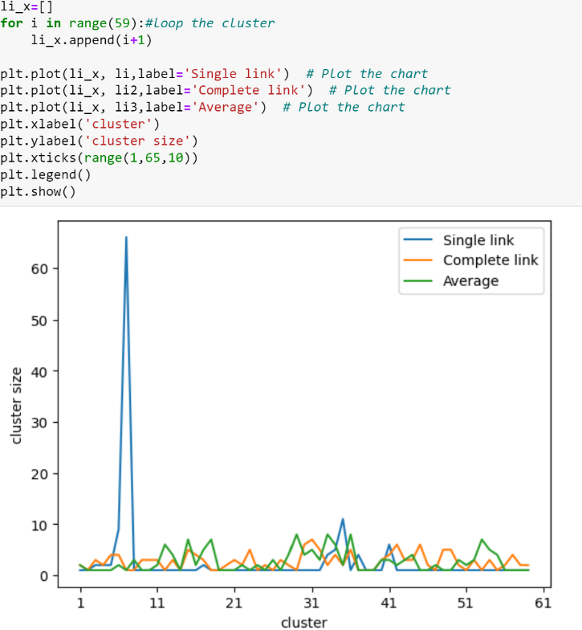

We can see that when k=59 (step102) in single link approach, most of the points (66 out of 161) are packed into one cluster (cluster 7). The points are not evenly distributed. This is the result of preferring cluster merging. Large size clusters are more likely to be formed.

In contrast, the distribution of points for complete link and group averages is more even. It means that by NOT preferring cluster merging, we can still have the 59 clusters with similar proportions of points at this stage.

We can further study the distribution of points for a smaller number of clusters (formed in later iterations). Let’s see the case for k=3.

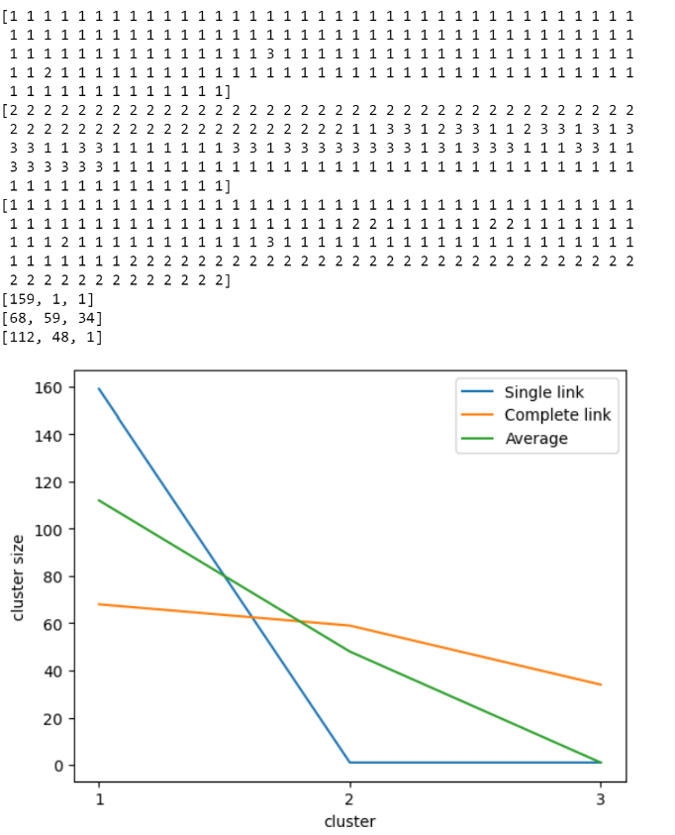

We can see that the situation for k=3 is similar to the situation for k=59. It is shown that the most uneven distribution of points among clusters is obtained through Single link method. This method gives 3 clusters with corresponding number of points being [159,1,1]. This is the cluster solution by preferring cluster-point/cluster-to-cluster merging. The range of the distribution is 158 and it is very large for the distribution of 161 data. The distribution of points in these clusters can be considered as unevenly distributed, with one cluster being very large and other clusters being very small.

The opposite is the complete link method. By using this method, we can produce 3 clusters with each of the clusters having similar number of items. For the example here, the 3 clusters contain 68,59,34 items respectively. The range of distribution is only 34, which can be considered as an even distribution. The reason we can have such even distribution is that we don’t prefer cluster merging compared to point to point merging. In that way, we could possibly form many small clusters without expanding a particular cluster too much.

Again, the Group average method sits somewhere between Single link and Complete link. The distribution of points under this method is [112,48,1] when k=3. It means that there are one large cluster, one medium size cluster and one smaller size cluster. The range of distribution is 111. It is not evenly distributed compared to complete link, but it is also not unevenly distributed like Single-link does.

**Small Summary for PART a**

The hierarchical structure of clusters generated by three different methods are different in both merge distance and merge size.

The merge distance of Single links tends to be smaller, while merge distance of Complete link tends to be larger. The group average just sits between the two.

The merge size of cluster in Single link tends to be larger (One cluster would include more points), and the distribution of points in different clusters tends to be more uneven. In opposite, the merge size of cluster in complete link tends to be smaller larger (One cluster would include fewer points), and the distribution of points in different clusters tends to be more even. The group average just sits between the two.

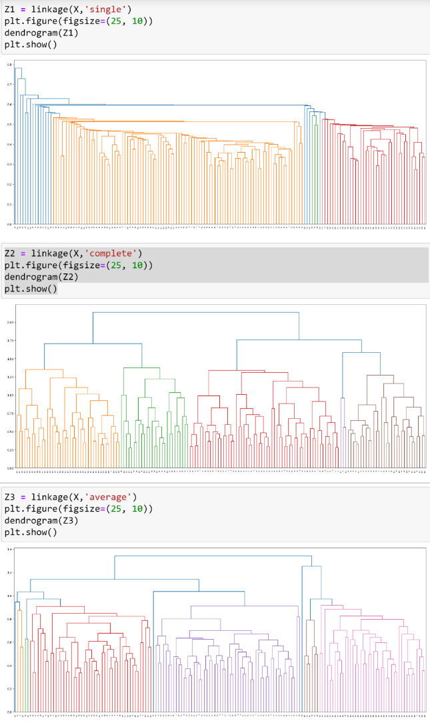

## (b) For some of these hierarchical structures, observe the set of distance values at which cluster merge occurs, and identify possible patterns from these values. (20%)

### Single Link

We first consider the set of distance values for single link. We plot all the distance values with respect to the number of iterations:

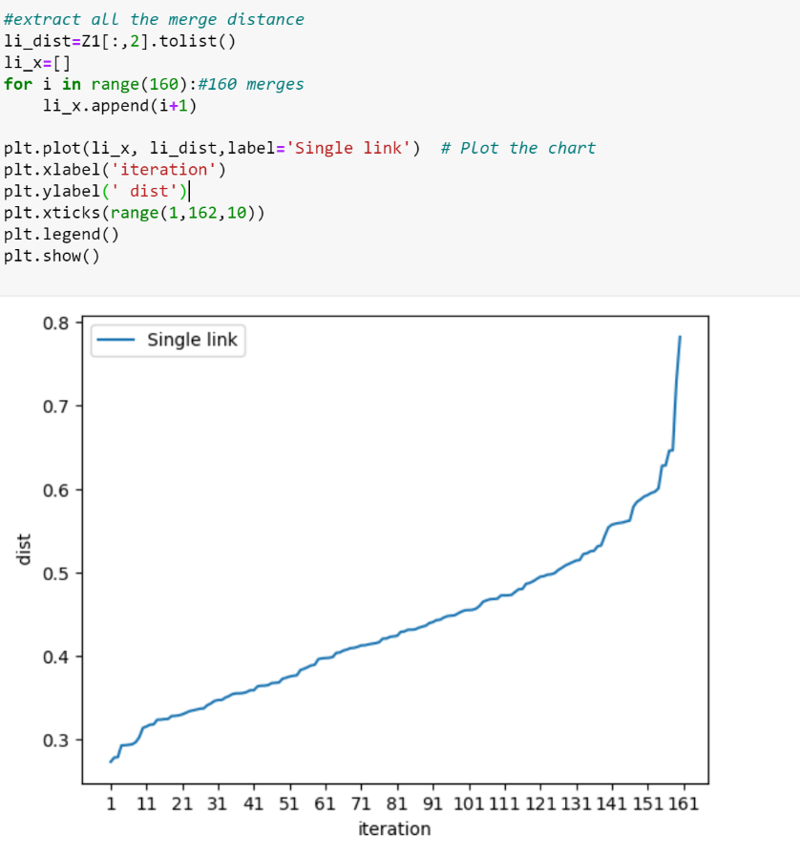

It is shown that the distance values increase at a stable pace. The big jump of merge distances only occurs in the last 20 iterations.

We can further derive the distance jump by taking the merge distance between every two iterations:

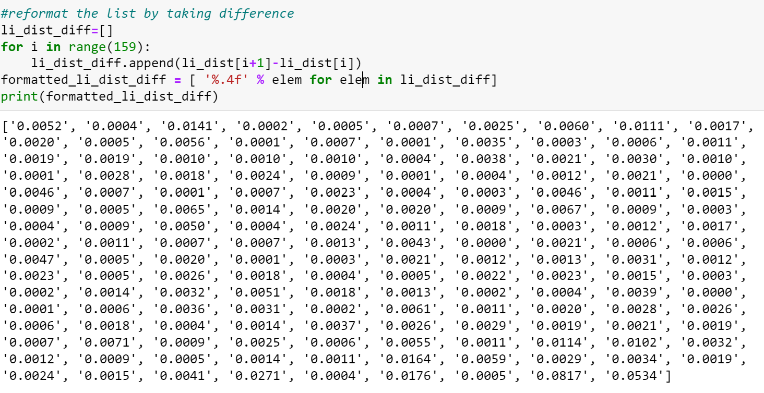

We can see that most of the jump distances are similar and lie between 0.0001 and 0.01. However, there are some big jumps (with jump values>0.01) discovered in the list. Most of them lie in the last part of the list:

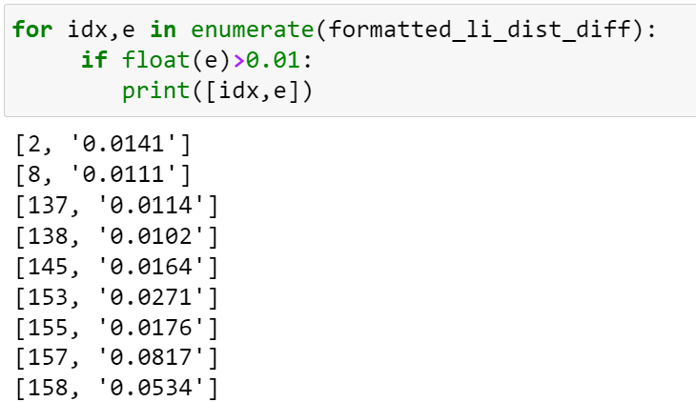

These are the set of thresholds we could consider for selecting an optimal clustering solution. The selection criteria is that we want to avoid having big jumps and also the number of clusters should not be too large.

For this purpose, we can sort all the jump distances, and select the top 4 largest jump from it:

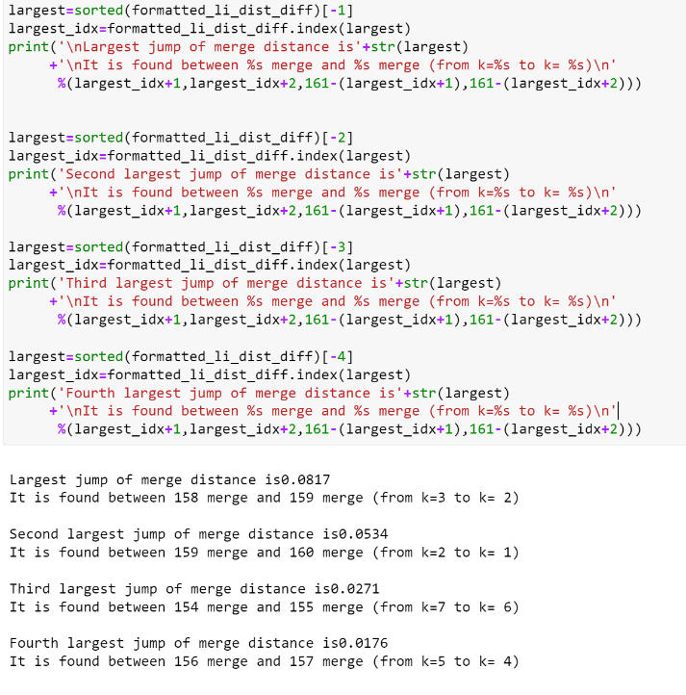

In this case, k=7 is one of the optimal clustering solutions we can select. It is shown that after 154th merges, the jump of the merge distances starts exceeding the usual jump values (0.0271). This implies that we are merging clusters that should not be merged. If we select k=7, the 4 largest distance jumps can be avoided. K=7 produced in merge step 154 is one of the optimal solutions. It is better not to proceed further.

The corresponding clustering solution should be:

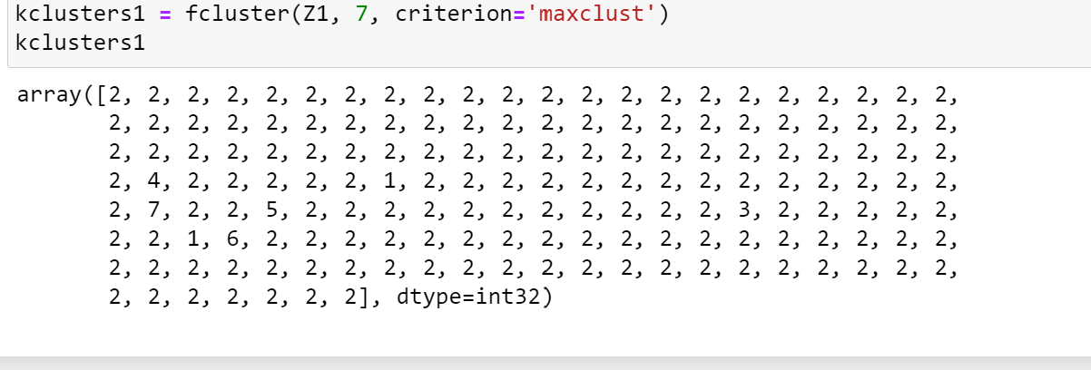

Apart from this solution, another solution we can select is k=15, this is derived from the fifth largest jump. In that way, we can avoid more large distance jumps. On the other hand, we are also having more clusters as our solution:

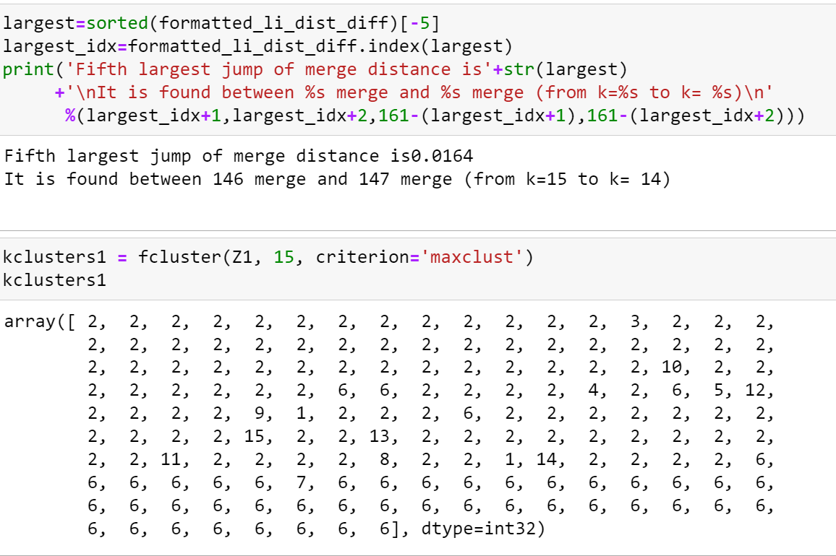

### Complete Link

We can also analyze the distance jump for the complete link case.

Similar, we obtain the merge distance trend:

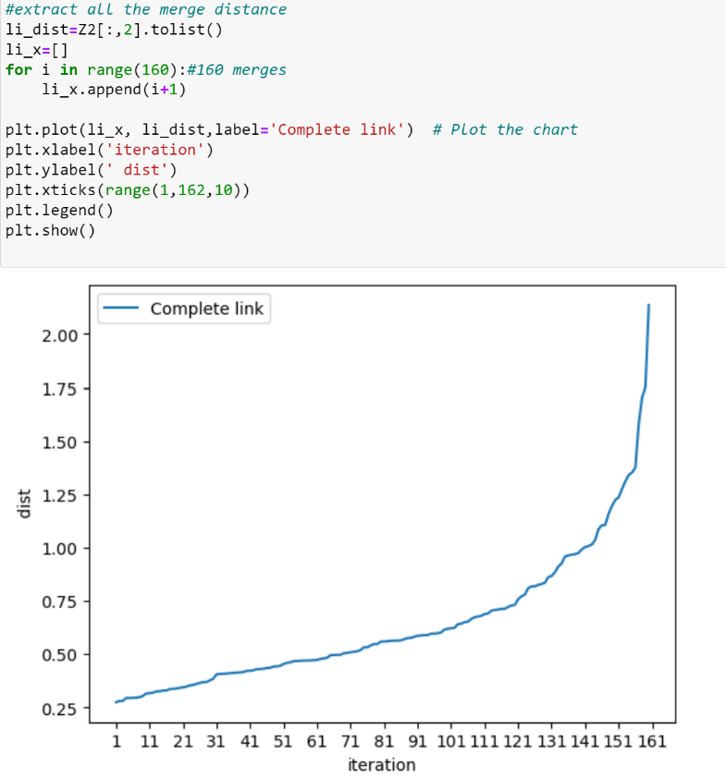

We can see that the situation is the same as the situation of single link. The distance increased in a predictable pace for most of the iterations. There is only a sudden increase in the distance jump starting from last 20 iterations.

We can derived the list of jump distances by taking the difference of every two merge differences:

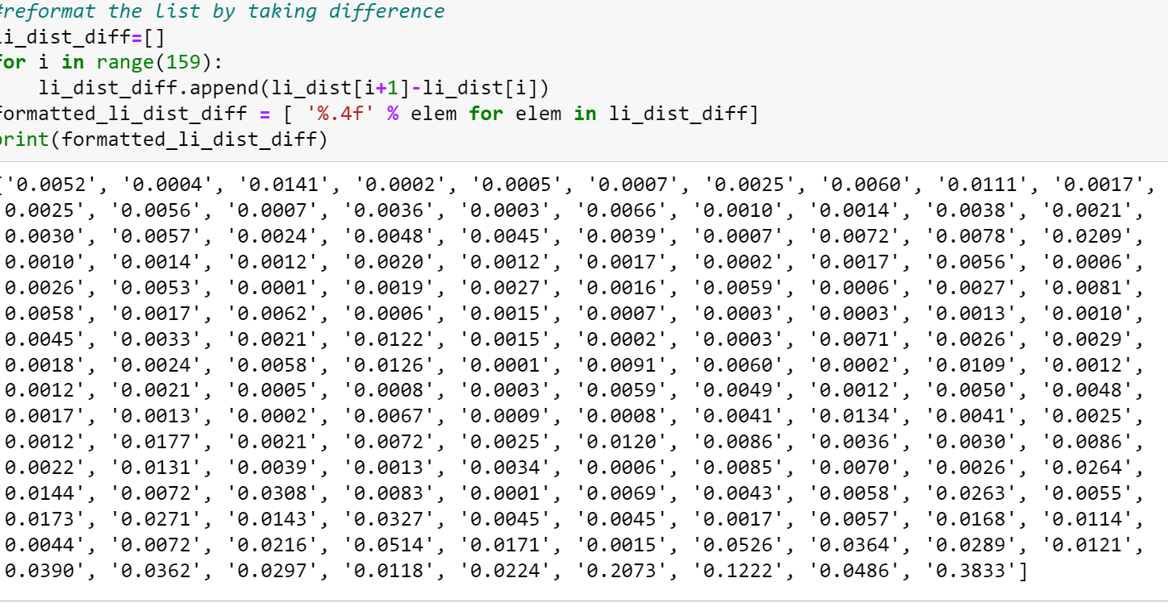

We can see that most of the value lies between 0.001 and 0.04. For value over 0.05, we can defined that as unusual big jump. Their corresponding index and distance jump are:

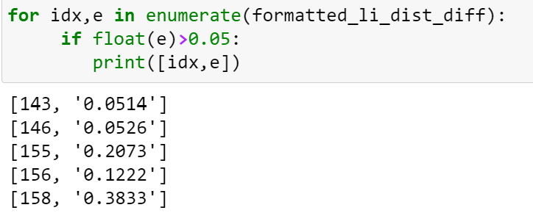

Their corresponding merge step and k values are:

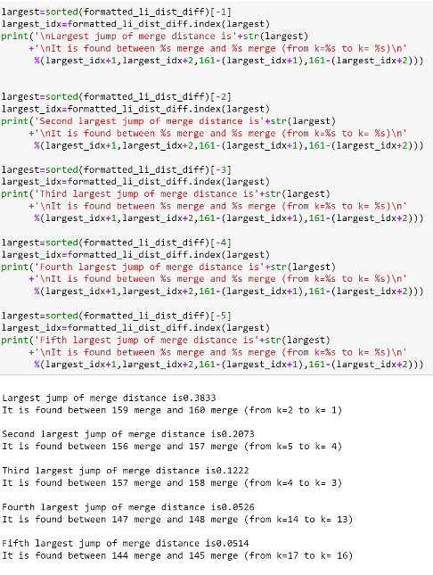

Therefore, k=2,k=5,k=4,k=14,k=17 are all possible solutions. We can choose k=5 such that the cluster solution can avoid 3 big jumps, or we can choose k=14 such that the cluster solution can avoid 4 big jumps, or we can choose k=17 such that the cluster solution can avoid 5 big jumps.

## (c)Select different clustering solutions from the hierarchical structures, and compare the cluster groupings with the corresponding K-means clustering solutions (using the method KMeans from the module sklearn.cluster), in terms of the extent to which the clusters can capture the class structure of the data set. (30%)

To start with, lets recap the **ground truth** for the 161 records:

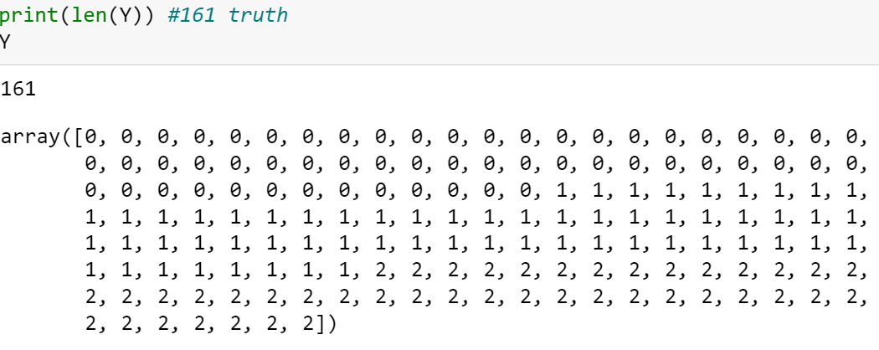

There are :

57 samples belong to class 1,

61 samples belong to class 2,

43 samples belong to class 3.

### K=3

Since there are 3 classes in the original data, we consider doing a comparison on k=3 first:

**K-Means clustering**

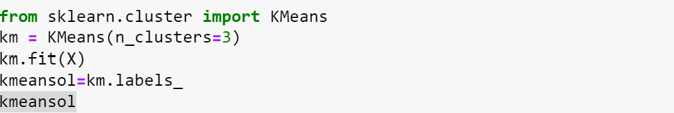

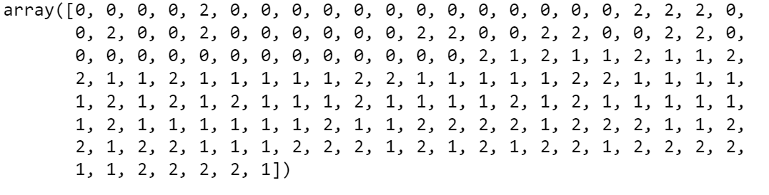

By converting to original class:

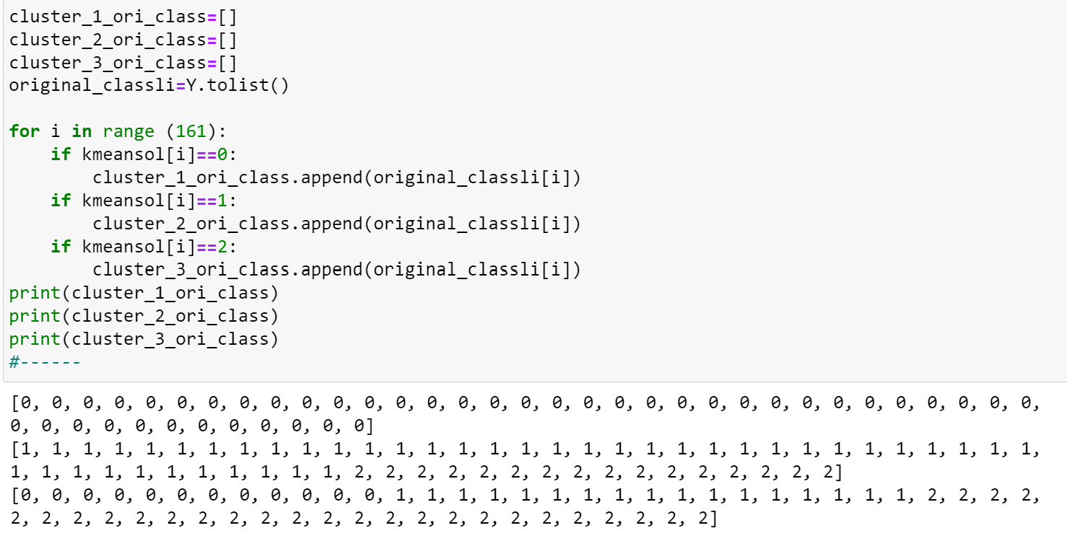

**Hierarchical clustering (Single link)**

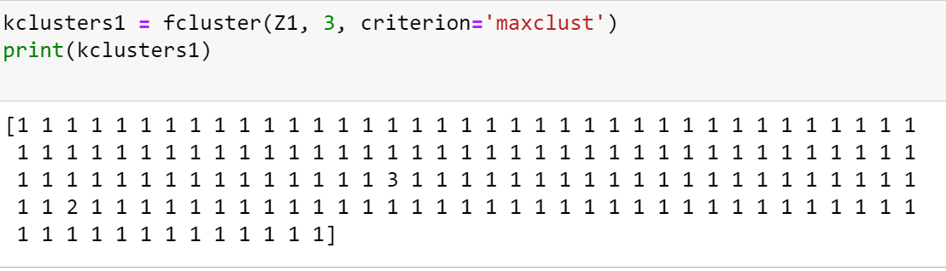

By converting to original class:

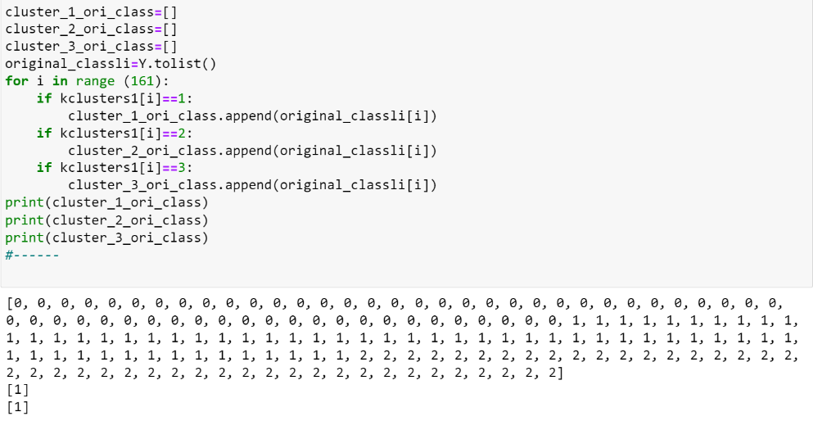

|  |  |  |  |  |  |  |  |  |  |  |  |  |  |  |  |  |  |  |  |  |  |  |  |  |  |  |  |  |  |  |  |  |  |  |  |  |  |  |  |  |  |  |  |  |  |  |  |  |  |  |  |  |  |  |  |  |  |  |  |  |
| --- | --- | --- | --- | --- | --- | --- | --- | --- | --- | --- | --- | --- | --- | --- | --- | --- | --- | --- | --- | --- | --- | --- | --- | --- | --- | --- | --- | --- | --- | --- | --- | --- | --- | --- | --- | --- | --- | --- | --- | --- | --- | --- | --- | --- | --- | --- | --- | --- | --- | --- | --- | --- | --- | --- | --- | --- | --- | --- | --- | --- |
| **Hierarchical clustering (Complete Link)**  **Hierarchical clustering (Group average)**    The result can be interpreted in the table below (majority class within each cluster are highlighted in yellow):   |  |  |  |  |  |  | | --- | --- | --- | --- | --- | --- | | K=3 | Original class | K-Means clustering  solution | Hierarchical clustering (Single link) solution | Hierarchical clustering (Complete link) solution | Hierarchical clustering (Group Average) solution | | Cluster 1 | Class 0 | 45/45 | 57/159 | 0/68 | 57/112 | | Class 1 | 0/45 | 59/159 | 25/68 | 55/112 | | Class 2 | 0/45 | 43/159 | 43/68 | 0/112 | | Cluster 2 | Class 0 | 0/60 | 0/1 | 57/59 | 0/48 | | Class 1 | 44/60 | 1/1 | 2/59 | 5/48 | | Class 2 | 16/60 | 0/1 | 0/59 | 43/48 | | Cluster 3 | Class 0 | 12/56 | 0/1 | 0/34 | 0/1 | | Class 1 | 17/56 | 1/1 | 34/34 | 1/1 | | Class 2 | 27/56 | 0/1 | 0/34 | 0/1 | | Misclassified samples | | 45 | 100 | 27 | 60 | |

The performance of cluster grouping can be evaluated in two dimensions. First, to evaluate whether a cluster only consists of a particular class of points. Second, to evaluate whether there exists a cluster for representing each of the classes. If these two criteria are matched, the cluster solution can be considered as having good performance in capturing the class structure of the dataset.

We can see that the cluster groupings obtained by k-means have good performance in capturing the class structure of the dataset. Cluster 1 consists of a majority of points belong to class 0, Cluster 2 consists of a majority of points belong to class 1, Cluster 3 consists of a majority of points belong to class 2. The role of each cluster is distinguishable, and every cluster is representative enough for one of the classes.

**This is not the case for hierarchical clustering (single link).** We can see that for single link solution, there are no cluster responsible for representing class 0 and class 2. All the three clusters consist of a majority of points belong to class 1. All the points coming from class 0 and all the points coming from class 2 are grouped into cluster 1. That is an uneven distribution of points toward the three clusters. **The role of every cluster is less distinguishable compared to k-means.**

Hierarchical cluster (complete link) provides a better solution compared to the single link. **Same as the k-means solution, every cluster is consisting of a majority of points belonging to one of the classes.** The role of every cluster is clearly distinguishable. Furthermore**, the cluster solution can be said to be performing better compared to k-means**. From the result, we can see that 25 points are being mislabeled in cluster 1, 2 points are being mislabeled in cluster 2, and 0 point are being mislabeled in cluster 3. In total, there are **only 27 points being mislabeled, which is better than k-mean** where there are 45 points being mislabeled in total.

In terms of capturing the class structure, the group average method has also done a good job. We can see that for every cluster, there are a majority of points belong to one of the classes. **This is the same as k-means.** However**, this solution is considered worse** compared to the one provided by k-means. In total, there are 60 points being misclassified. The reason for that is that most of the points belong to class 2 are grouped into cluster 1, which is the representative cluster for class0. Even though the role of every cluster is distinguishable, **the grouping of the points is not desirable compared to k-means.**

In summary, for k=3, the performance of the cluster solution in capturing the class structure is ranked as follows:

Complete link>K-means>Group Average>Single Link

### K=10

We perform the same experiment for k=10 and obtain the following table:

|  |  |  |  |  |  |
| --- | --- | --- | --- | --- | --- |
| K=10 | Original class | K-Means clustering  solution | Hierarchical clustering (Single link) solution | Hierarchical clustering (Complete link) solution | Hierarchical clustering (Group Average) solution |
| Cluster 1 | Class 0 | 0/28 | 0/2 | 0/12 | 0/3 |
| Class 1 | 15/28 | 2/2 | 0/12 | 3/3 |
| Class 2 | 13/28 | 0/2 | 12/12 | 0/3 |
| Cluster 2 | Class 0 | 10/10 | 56/104 | 0/29 | 0/1 |
| Class 1 | 0/10 | 48/104 | 2/29 | 1/1 |
| Class 2 | 0/10 | 0/104 | 27/29 | 0/1 |
| Cluster 3 | Class 0 | 1/30 | 0/1 | 0/5 | 0/2 |
| Class 1 | 12/30 | 1/1 | 1/5 | 2/2 |
| Class 2 | 17/30 | 0/1 | 4/5 | 0/2 |
| Cluster 4 | Class 0 | 5/5 | 1/1 | 0/22 | 0/48 |
| Class 1 | 0/5 | 0/1 | 22/22 | 48/48 |
| Class 2 | 0/5 | 0/1 | 0/22 | 0/48 |
| Cluster 5 | Class 0 | 5/13 | 0/1 | 18/18 | 57/57 |
| Class 1 | 3/13 | 1/1 | 0/18 | 0/57 |
| Class 2 | 5/13 | 0/1 | 0/18 | 0/57 |
| Cluster 6 | Class 0 | 14/14 | 0/1 | 12/14 | 0/1 |
| Class 1 | 0/14 | 1/1 | 2/14 | 1/1 |
| Class 2 | 0/14 | 0/1 | 0/14 | 0/1 |
| Cluster 7 | Class 0 | 0/17 | 0/1 | 27/27 | 0/6 |
| Class 1 | 14/17 | 1/1 | 0/27 | 3/6 |
| Class 2 | 3/17 | 0/1 | 0/27 | 3/6 |
| Cluster 8 | Class 0 | 16/16 | 0/1 | 0/3 | 0/2 |
| Class 1 | 0/16 | 1/1 | 3/3 | 0/2 |
| Class 2 | 0/16 | 0/1 | 0/3 | 2/2 |
| Cluster 9 | Class 0 | 6/13 | 0/1 | 0/13 | 0/40 |
| Class 1 | 2/13 | 1/1 | 13/13 | 2/40 |
| Class 2 | 5/13 | 0/1 | 0/13 | 38/40 |
| Cluster 10 | Class 0 | 0/15 | 0/1 | 0/18 | 0/1 |
| Class 1 | 15/15 | 1/1 | 18/18 | 1/1 |
| Class 2 | 0/15 | 0/1 | 0/18 | 0/1 |
| # cluster representing class 0 | | 6 | 2 | 3 | 1 |
| # cluster representing class 1 | | 3 | 8 | 4 | 7 |
| # cluster representing class 2 | | 1 | 0 | 3 | 2 |
| Total Mis-labelled points | | 44 | 48 | 5 | 5 |

For k =10, k means can construct clusters responsible for each class. For example, 14 out of 14 points in cluster 6 belong to class 0. 15/15 points in cluster 10 belong to class 1. 17/30 points in cluster 3 belongs to class 2. Every cluster is composing of a majority of points belong to one particular class. The roles of most clusters are clear and distinguishable.

However, this is not the case for the single link hierarchical clustering solution. In this solution, there is no cluster responsible for representing class 2. Also, there are many class 1 points being grouped into cluster 2, which represents class 0. As a result, there are more mislabeled points under this solution. Furthermore, a lot more clusters are representing class 1, but the size of cluster is only 1. It shows that the distribution of points is uneven compared to k-means and the role of each cluster is also less representative compared to k-means.

On the other hand, the solution constructed using complete link hierarchical clustering is capturing more class structures compared to the k-means solution. First, it consists of clusters representing different classes, and the number of clusters representing each of the classes is quite even. There are 3 clusters representing class 0, 4 clusters representing class 1 and 3 clusters representing class 2. Also, there are fewer number of misclassified samples under this solution. These make the cluster solution have a more representative structure compared to k-means.

Finally, the solution constructed using group average hierarchical clustering is also better than that constructed using k-means. In this solution, there are also clusters representing each of the classes. For example, cluster 4 contains 48/48points from class1, cluster 5 contains 57/57 points from class 0 and cluster 9 contains 38/40 points from class 2. Most of the clusters are also representative and contain only a few numbers of mis-labelled points. To be precise, the number of mis-labelled points in group average hierarchical clustering is only 5, which is much fewer than the number of mis-labelled points in K-means. We can see that this solution outperforms k-means in capturing the class structure.

In summary, for k=10, the performance of the cluster solution in capturing the class structure is ranked as follows:

Complete link = Group Average >K-means >Single Link

## (d) Select different subsets of attributes from the data sets and re-perform hierarchical clustering. Compare the resulting hierarchical structures based on the selected attribute subsets with the original hierarchical structures. (20%)

### Preparation

To improve the clustering solution of hierarchical clustering, we select attributes that are most likely to be affecting the classification result. The way we do this is to construct a random forest classifier. We let the number of subtrees to be five and fit X and Y to the classifier. Then, we check the importance of every feature for every sub tree. The importance of an attribute is estimated based on the total importance of that attribute in all the subtrees.

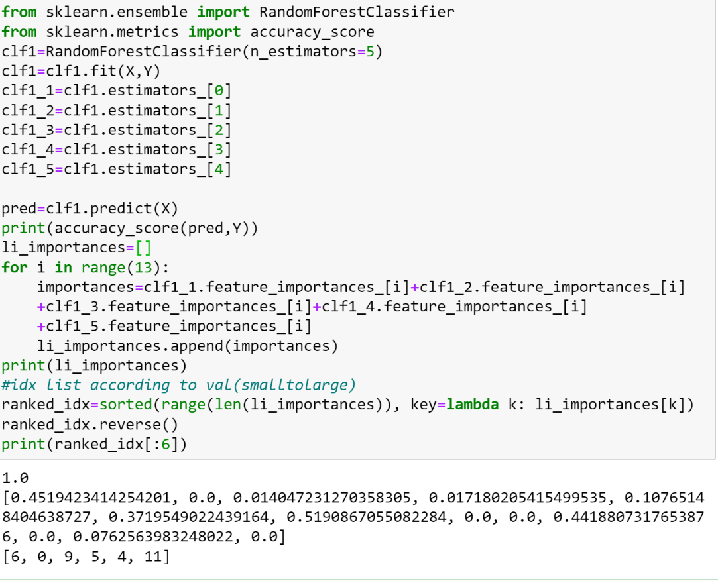

After calculating the importance values for every attribute, we take the top six and top three attributes for performing hierarchical clustering.

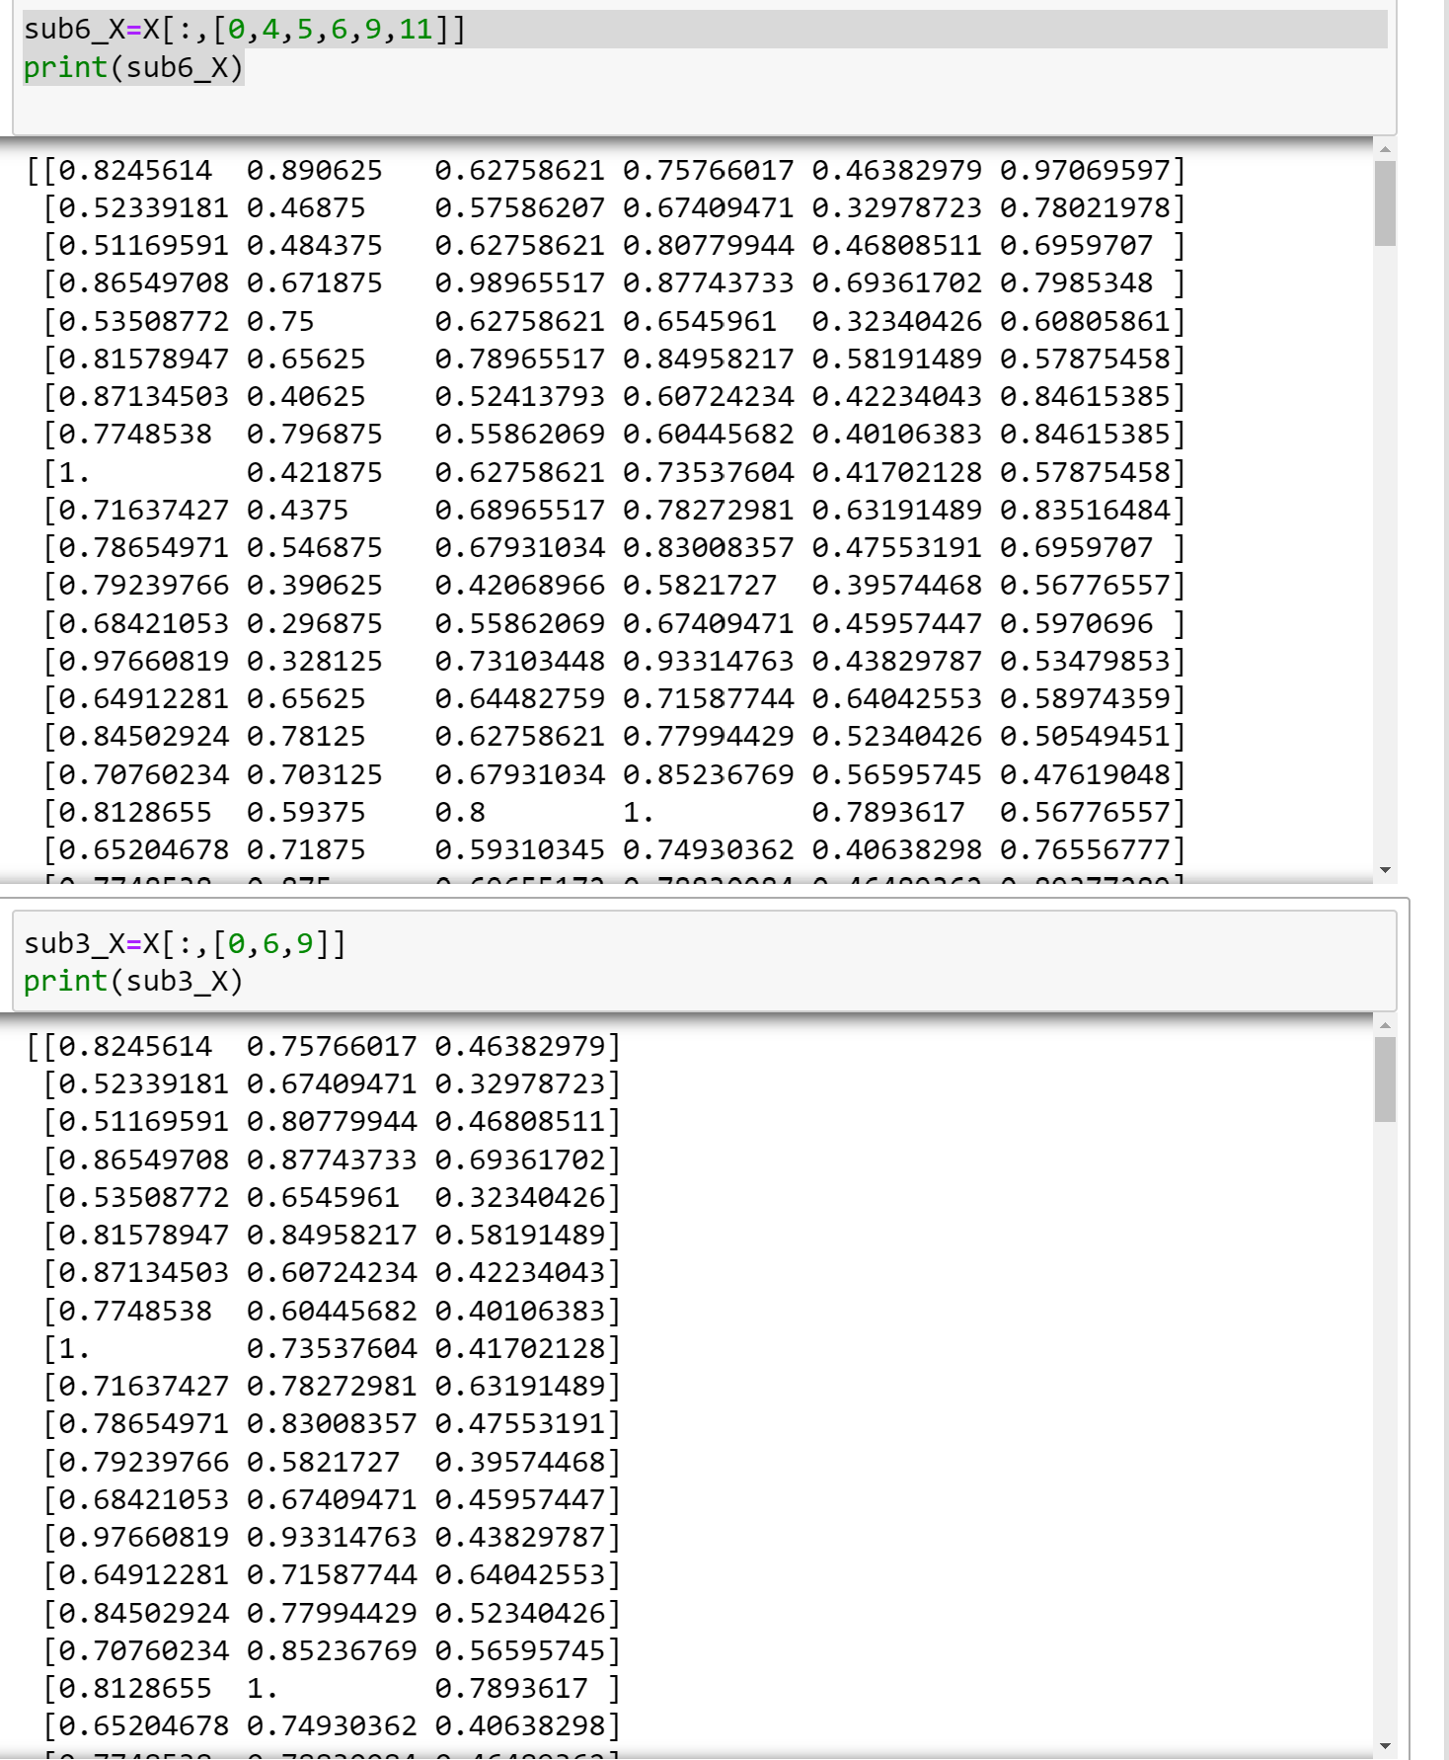

Then we construct the dendrogram using sub6_X and sub3_X

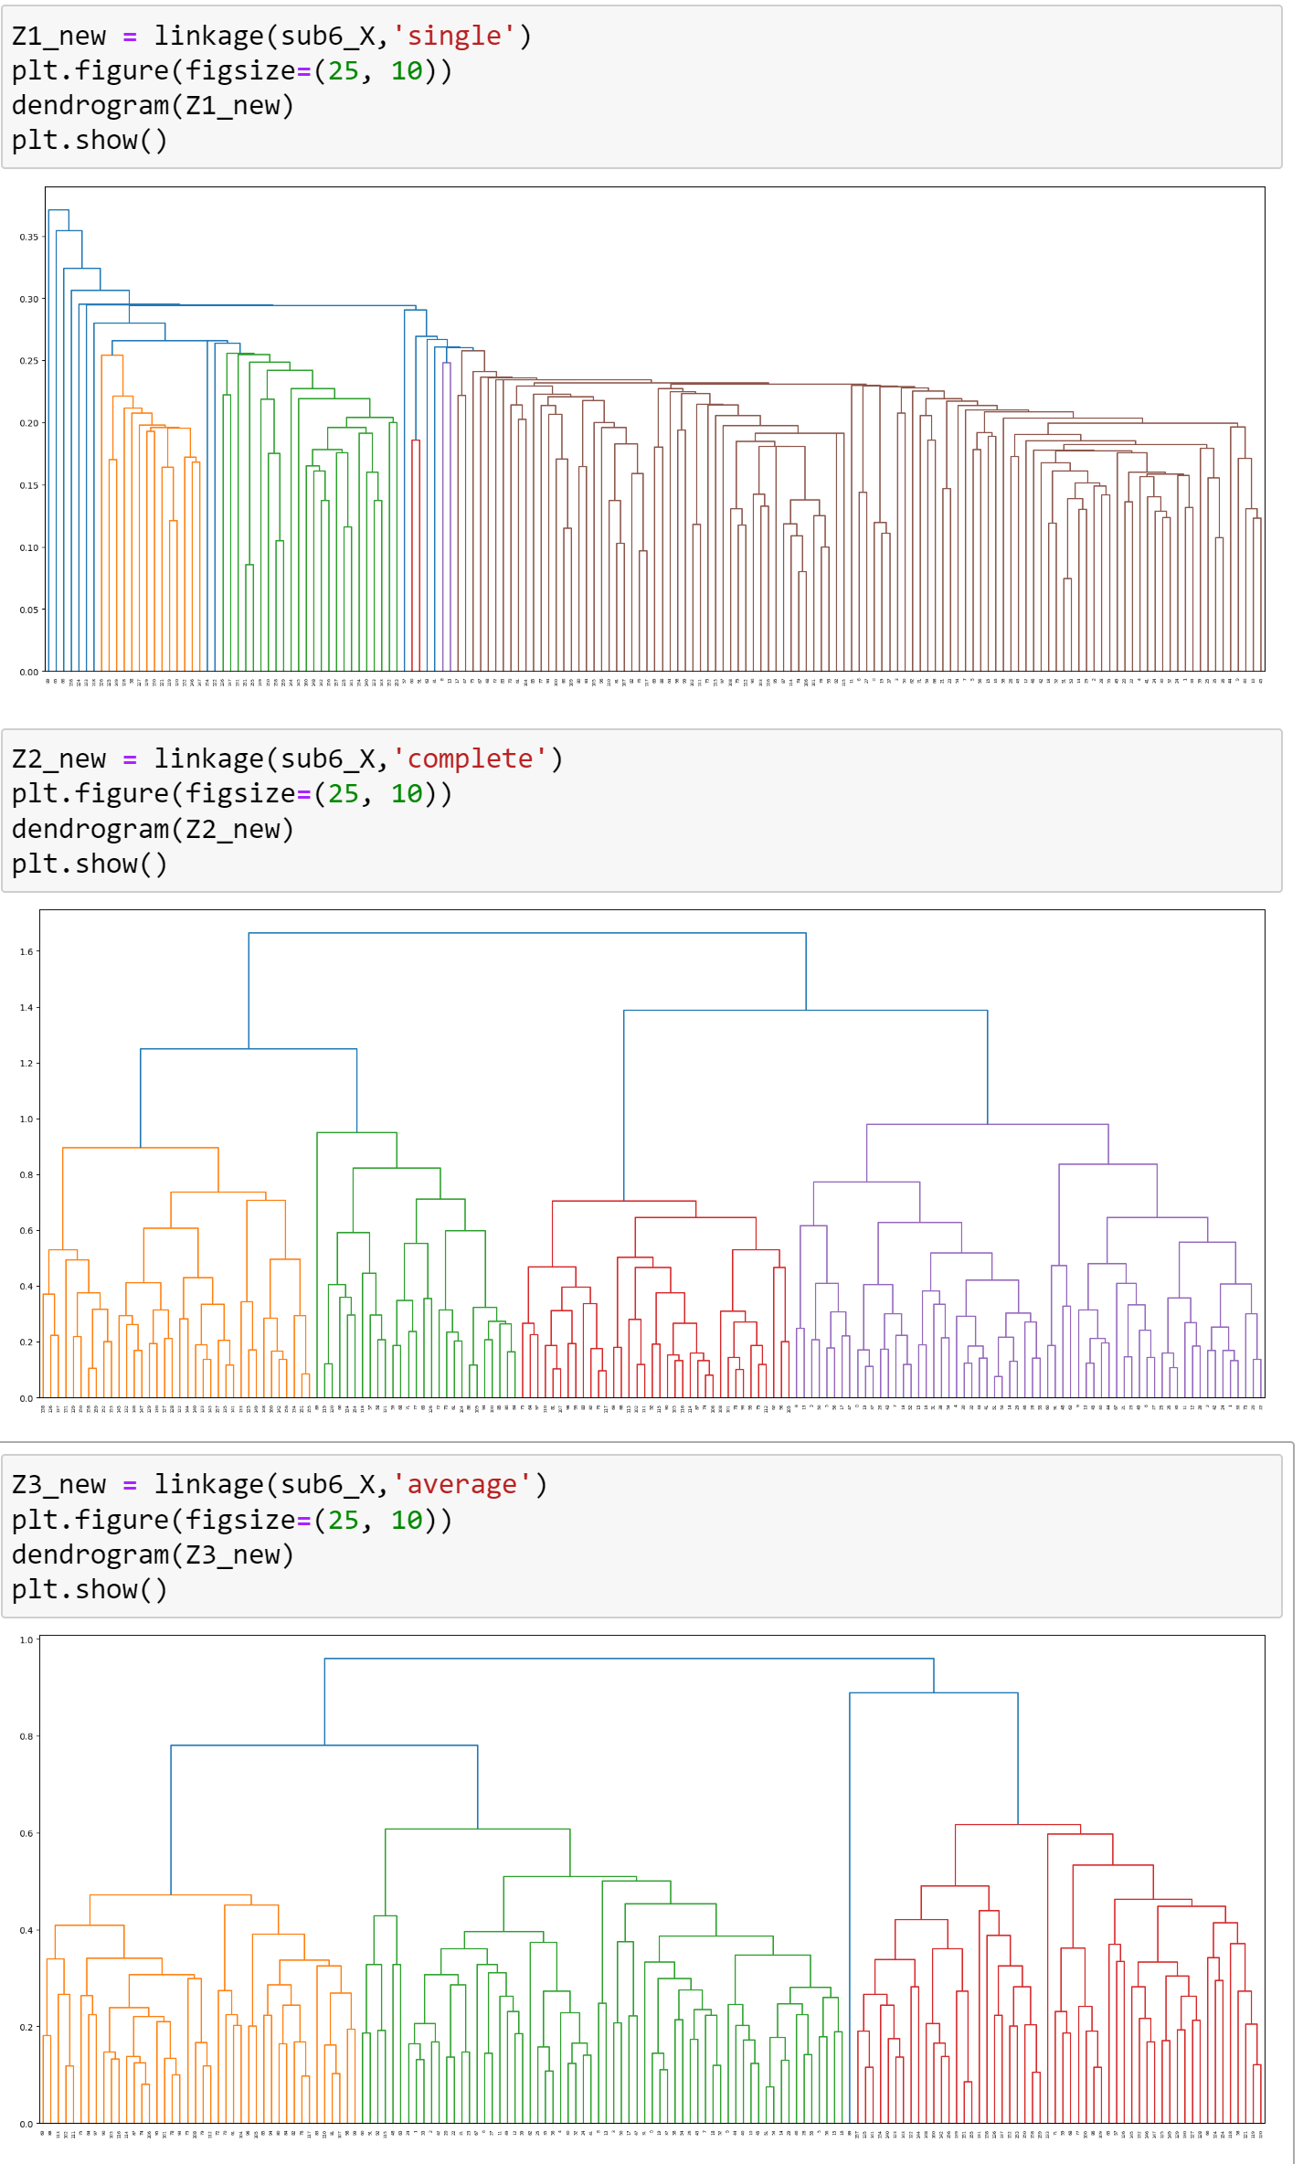

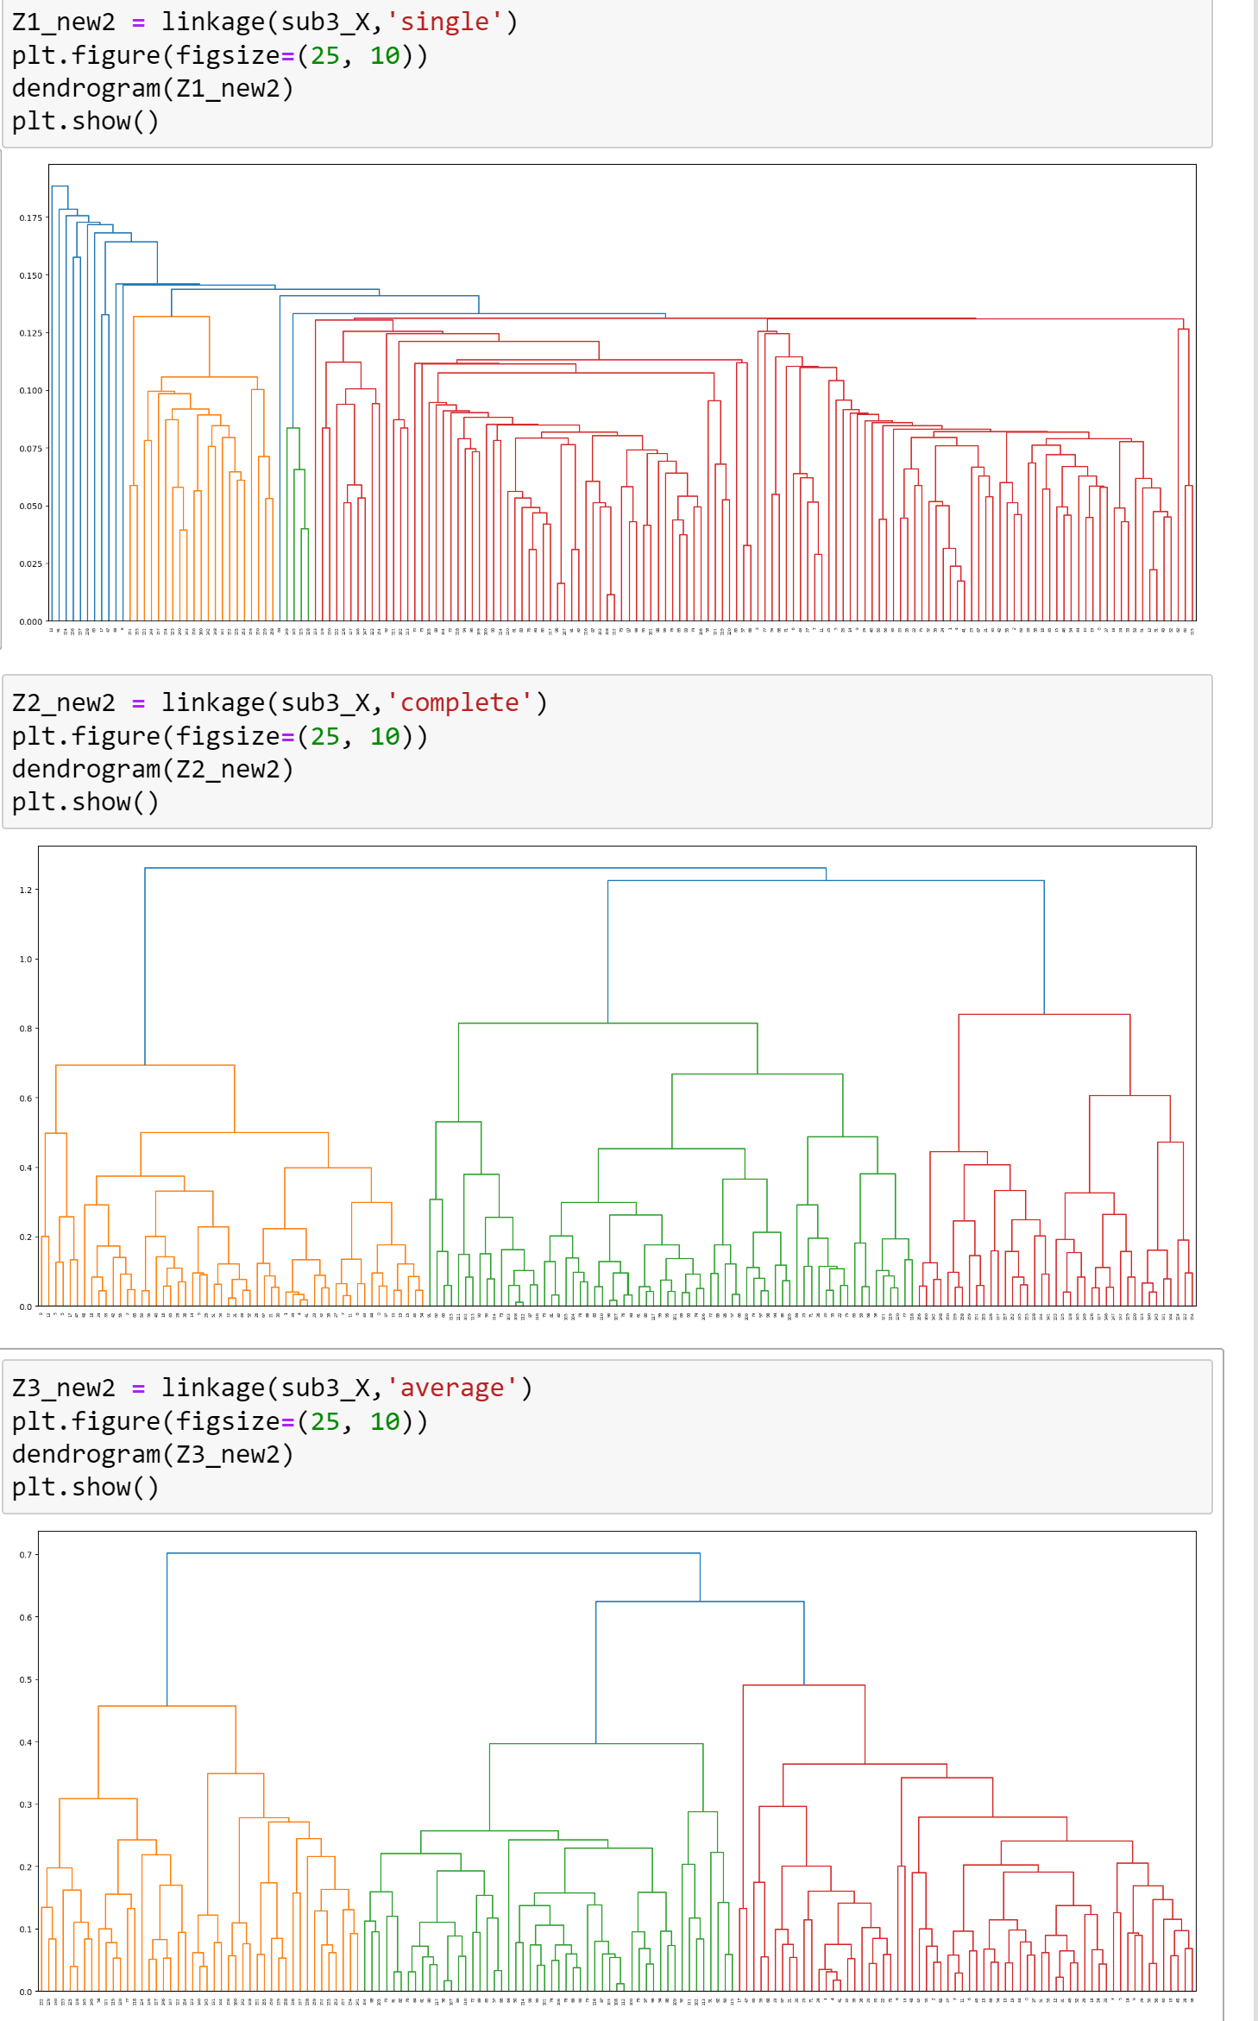

We can put the original dendrogram together for comparison:

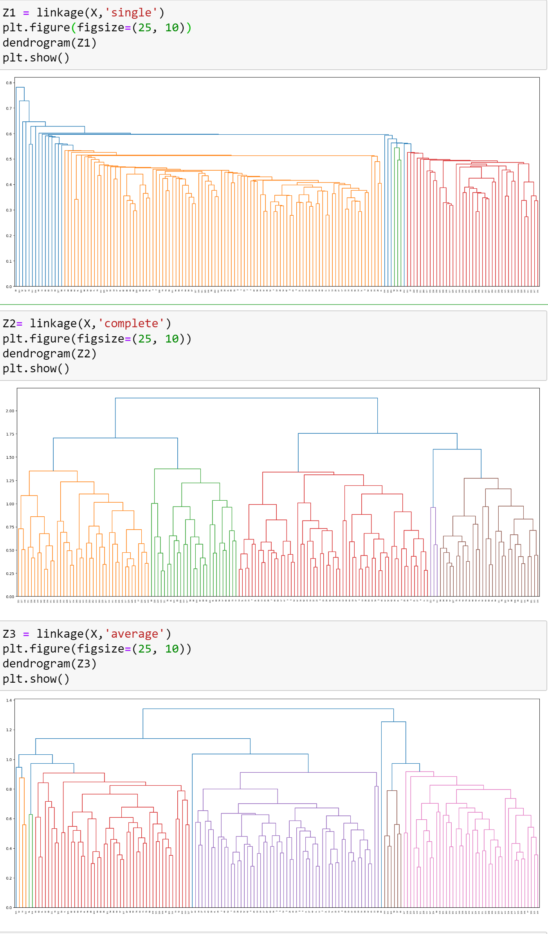

Just by observing the y-axis on dendrogram, we can see that the merge distance is shorter compared to the original one. The smaller the subset of attributes, the shorter the merge distance. Considering the merge size, we can see that the merge size of the clusters for the new dataset is smaller. We can further validate these claims by looking at the real numerical data.

### Effect on Merge Distance

We plot all the merge distances obtained by the recent hierarchical clustering. We then compare with those obtained from the original hierarchical clustering.

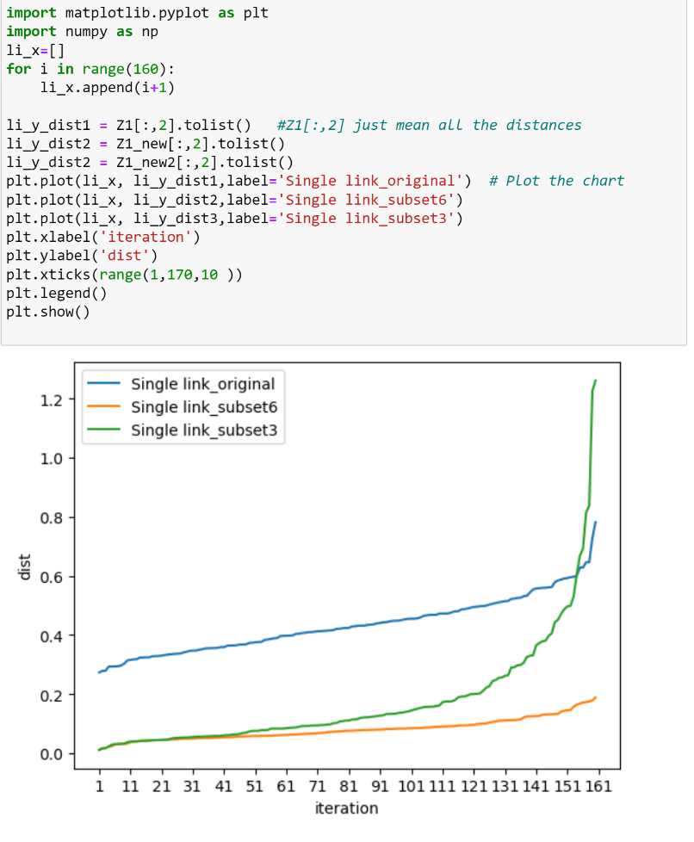

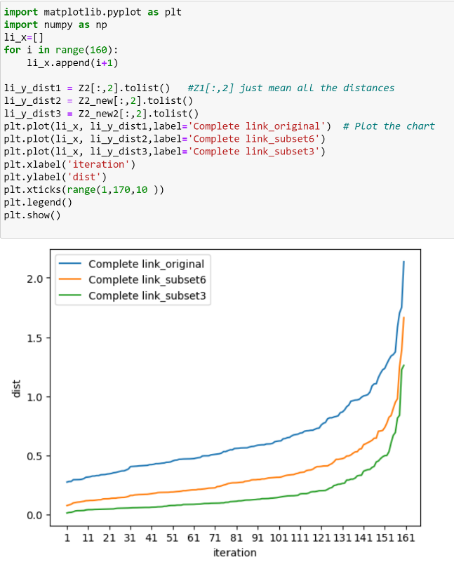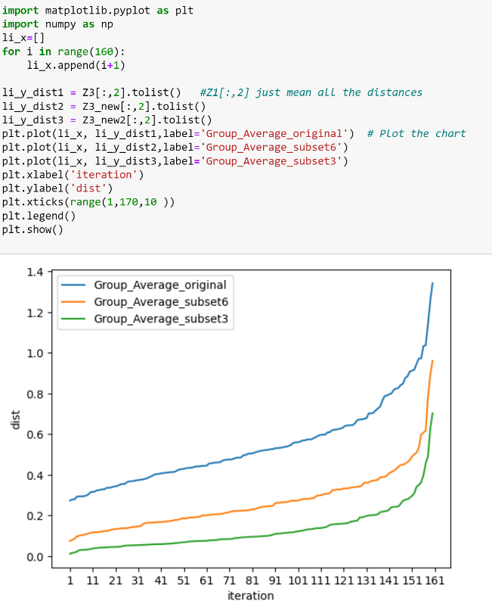



Obviously, we can see that all the **merge distances are dropped**. **The smaller the subset of attributes, the greater the drop in merge distance.** Also, for complete link and group average, the slope of those distance obtained using subset attributes are flatter compared to distance obtained using full set of attributes. The turning point of the line exists in a later iteration (annotated in red). The smaller the subset, the later the turning point is. It implies that **the increases in merge distances is slower** when we are extracting useful attributes. The clustering algorithm can find points with shorter distances, and therefore, able to perform a **smoother merging with fewer big jumps in merge distance**. This is also shown on the graph: the big jumps are found after 140th iterations if we use the original dataset, it is only found after 150th iterations if we use the subset_6. The turning point is delayed. It means that the optimal clustering solution can be achieved in a later iteration.

We can validate these claims by looking at the merging distance for every point:

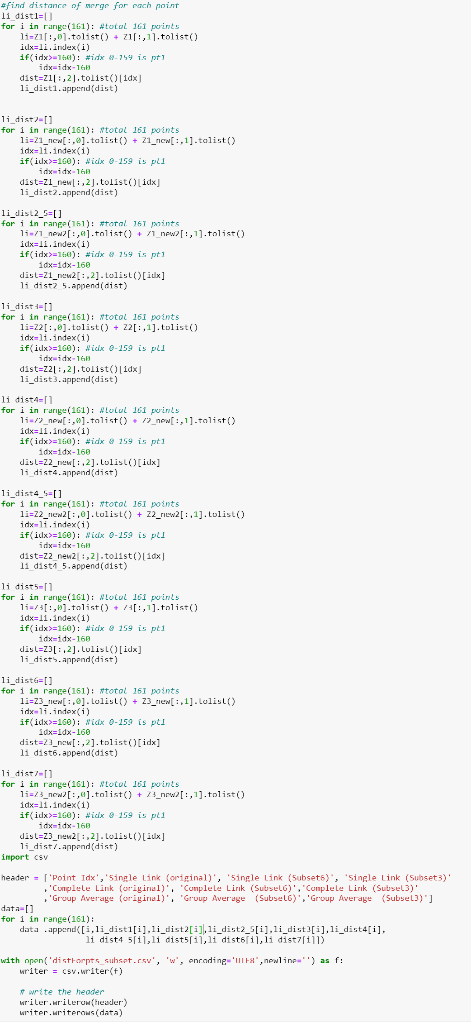

The result are shown below:

|  |  |  |  |  |  |  |  |  |  |
| --- | --- | --- | --- | --- | --- | --- | --- | --- | --- |
| Point Idx | Single Link (original) | Single Link (Subset6) | Single Link (Subset3) | Complete Link (original) | Complete Link (Subset6) | Complete Link (Subset3) | Group Average (original) | Group Average (Subset6) | Group Average (Subset3) |
| 0 | 0.293638 | 0.119701 | 0.05779 | 0.293638 | 0.169553 | 0.05779 | 0.293638 | 0.144627 | 0.05779 |
| 1 | 0.431889 | 0.131453 | 0.023616 | 0.512728 | 0.131453 | 0.039894 | 0.472309 | 0.131453 | 0.030865 |
| 2 | 0.455366 | 0.149076 | 0.046123 | 0.46906 | 0.167427 | 0.046123 | 0.462213 | 0.167427 | 0.046123 |
| 3 | 0.414047 | 0.207377 | 0.125396 | 0.452478 | 0.207377 | 0.125396 | 0.443522 | 0.207377 | 0.125396 |
| 4 | 0.459964 | 0.156307 | 0.017246 | 0.459964 | 0.290971 | 0.017246 | 0.459964 | 0.227604 | 0.017246 |
| 5 | 0.368292 | 0.178267 | 0.09554 | 0.368292 | 0.178267 | 0.125396 | 0.368292 | 0.178267 | 0.125396 |
| 6 | 0.329016 | 0.143589 | 0.063894 | 0.430799 | 0.143589 | 0.063894 | 0.379908 | 0.143589 | 0.063894 |
| 7 | 0.429477 | 0.209964 | 0.028856 | 0.56328 | 0.223332 | 0.028856 | 0.530438 | 0.222765 | 0.028856 |
| 8 | 0.436424 | 0.248065 | 0.145371 | 0.479742 | 0.248065 | 0.200283 | 0.51608 | 0.248065 | 0.200283 |
| 9 | 0.278463 | 0.170898 | 0.089364 | 0.278463 | 0.313467 | 0.089364 | 0.278463 | 0.245223 | 0.089364 |
| 10 | 0.363716 | 0.1233 | 0.044674 | 0.363716 | 0.1233 | 0.044674 | 0.363716 | 0.1233 | 0.044674 |
| 11 | 0.278891 | 0.230002 | 0.028856 | 0.278891 | 0.267764 | 0.028856 | 0.278891 | 0.262451 | 0.028856 |
| 12 | 0.278891 | 0.185366 | 0.022187 | 0.278891 | 0.185366 | 0.022187 | 0.278891 | 0.185366 | 0.022187 |
| 13 | 0.584851 | 0.248065 | 0.188453 | 0.817419 | 0.248065 | 0.200283 | 0.817419 | 0.248065 | 0.200283 |
| 14 | 0.293149 | 0.130033 | 0.090042 | 0.293149 | 0.130033 | 0.095207 | 0.293149 | 0.130033 | 0.092625 |
| 15 | 0.302857 | 0.188626 | 0.049342 | 0.302857 | 0.188626 | 0.084707 | 0.302857 | 0.188626 | 0.067024 |
| 16 | 0.302857 | 0.188626 | 0.057062 | 0.302857 | 0.188626 | 0.057062 | 0.302857 | 0.188626 | 0.057062 |
| 17 | 0.384753 | 0.221568 | 0.132657 | 0.44165 | 0.221568 | 0.132657 | 0.44165 | 0.221568 | 0.132657 |
| 18 | 0.420984 | 0.118881 | 0.048813 | 0.420984 | 0.118881 | 0.08361 | 0.420984 | 0.118881 | 0.066211 |
| 19 | 0.293638 | 0.110668 | 0.044674 | 0.293638 | 0.110668 | 0.044674 | 0.293638 | 0.110668 | 0.044674 |
| 20 | 0.489662 | 0.136079 | 0.044379 | 0.596116 | 0.136079 | 0.044379 | 0.581179 | 0.136079 | 0.044379 |
| 21 | 0.328066 | 0.146717 | 0.053815 | 0.328066 | 0.146717 | 0.053815 | 0.328066 | 0.146717 | 0.053815 |
| 22 | 0.313926 | 0.136079 | 0.058663 | 0.313926 | 0.136079 | 0.058663 | 0.313926 | 0.136079 | 0.058663 |
| 23 | 0.313926 | 0.146717 | 0.066525 | 0.313926 | 0.146717 | 0.087233 | 0.313926 | 0.146717 | 0.098391 |
| 24 | 0.334958 | 0.157669 | 0.04284 | 0.334958 | 0.169302 | 0.04284 | 0.334958 | 0.163485 | 0.04284 |
| 25 | 0.3245 | 0.155258 | 0.104074 | 0.3245 | 0.160335 | 0.11402 | 0.3245 | 0.157797 | 0.11402 |
| 26 | 0.431574 | 0.172565 | 0.091448 | 0.459964 | 0.172565 | 0.12306 | 0.459964 | 0.172565 | 0.123035 |
| 27 | 0.328066 | 0.143589 | 0.051473 | 0.328066 | 0.143589 | 0.063538 | 0.328066 | 0.143589 | 0.057505 |
| 28 | 0.454881 | 0.141822 | 0.068466 | 0.495998 | 0.141822 | 0.068466 | 0.475341 | 0.141822 | 0.068466 |
| 29 | 0.363716 | 0.130033 | 0.086719 | 0.363716 | 0.130033 | 0.089364 | 0.363716 | 0.130033 | 0.089364 |
| 30 | 0.447871 | 0.123675 | 0.053815 | 0.563548 | 0.123675 | 0.053815 | 0.537813 | 0.123675 | 0.053815 |
| 31 | 0.44609 | 0.260742 | 0.022187 | 0.56328 | 0.334642 | 0.022187 | 0.512744 | 0.332681 | 0.022187 |
| 32 | 0.29432 | 0.123675 | 0.051703 | 0.29432 | 0.123675 | 0.051703 | 0.29432 | 0.123675 | 0.051703 |
| 33 | 0.330119 | 0.131453 | 0.04284 | 0.407872 | 0.131453 | 0.04284 | 0.368996 | 0.131453 | 0.04284 |
| 34 | 0.359078 | 0.128832 | 0.031347 | 0.420336 | 0.140107 | 0.032122 | 0.389707 | 0.140107 | 0.034454 |
| 35 | 0.29432 | 0.10735 | 0.044379 | 0.29432 | 0.10735 | 0.044379 | 0.29432 | 0.10735 | 0.044379 |
| 36 | 0.3245 | 0.10735 | 0.082942 | 0.3245 | 0.10735 | 0.11412 | 0.3245 | 0.10735 | 0.101984 |
| 37 | 0.420984 | 0.110668 | 0.05779 | 0.420984 | 0.110668 | 0.05779 | 0.420984 | 0.110668 | 0.05779 |
| 38 | 0.31567 | 0.203267 | 0.068466 | 0.31567 | 0.213714 | 0.068466 | 0.31567 | 0.213714 | 0.068466 |
| 39 | 0.404285 | 0.179438 | 0.049967 | 0.404285 | 0.185366 | 0.051703 | 0.404285 | 0.185366 | 0.051703 |
| 40 | 0.411095 | 0.130882 | 0.085773 | 0.411095 | 0.196293 | 0.141268 | 0.411095 | 0.17125 | 0.115269 |
| 41 | 0.404285 | 0.140107 | 0.017246 | 0.404285 | 0.140107 | 0.017246 | 0.404285 | 0.140107 | 0.017246 |
| 42 | 0.355751 | 0.167427 | 0.05989 | 0.423565 | 0.167427 | 0.139496 | 0.412704 | 0.167427 | 0.100027 |
| 43 | 0.510498 | 0.172565 | 0.062073 | 0.540379 | 0.172565 | 0.063894 | 0.525438 | 0.172565 | 0.063894 |
| 44 | 0.531599 | 0.196293 | 0.06287 | 0.588569 | 0.196293 | 0.095183 | 0.574342 | 0.20167 | 0.079027 |
| 45 | 0.278463 | 0.1233 | 0.057062 | 0.278463 | 0.1233 | 0.057062 | 0.278463 | 0.1233 | 0.057062 |
| 46 | 0.406701 | 0.177782 | 0.045765 | 0.406701 | 0.269752 | 0.045765 | 0.406701 | 0.223767 | 0.045765 |
| 47 | 0.398826 | 0.221568 | 0.132657 | 0.44165 | 0.221568 | 0.132657 | 0.44165 | 0.221568 | 0.132657 |
| 48 | 0.601001 | 0.236092 | 0.146102 | 0.817419 | 0.327815 | 0.290069 | 0.817419 | 0.327815 | 0.189349 |
| 49 | 0.372886 | 0.175707 | 0.045037 | 0.495542 | 0.24141 | 0.045037 | 0.427952 | 0.230783 | 0.045037 |
| 50 | 0.368292 | 0.207377 | 0.044074 | 0.368292 | 0.207377 | 0.044074 | 0.368292 | 0.207377 | 0.044074 |
| 51 | 0.293149 | 0.074717 | 0.057511 | 0.293149 | 0.074717 | 0.061696 | 0.293149 | 0.074717 | 0.061696 |
| 52 | 0.332036 | 0.118881 | 0.045037 | 0.423565 | 0.118881 | 0.045037 | 0.426263 | 0.118881 | 0.045037 |
| 53 | 0.406701 | 0.074717 | 0.061696 | 0.406701 | 0.074717 | 0.061696 | 0.406701 | 0.074717 | 0.061696 |
| 54 | 0.31567 | 0.213714 | 0.045765 | 0.31567 | 0.213714 | 0.045765 | 0.31567 | 0.213714 | 0.045765 |
| 55 | 0.333912 | 0.141822 | 0.051103 | 0.334958 | 0.141822 | 0.092247 | 0.334958 | 0.141822 | 0.071675 |
| 56 | 0.411095 | 0.178267 | 0.044074 | 0.411095 | 0.178267 | 0.044074 | 0.411095 | 0.178267 | 0.044074 |
| 57 | 0.495746 | 0.290629 | 0.03263 | 0.495746 | 0.29492 | 0.03263 | 0.495746 | 0.333558 | 0.03263 |
| 58 | 0.544035 | 0.207693 | 0.095457 | 0.575583 | 0.207693 | 0.102198 | 0.559809 | 0.272453 | 0.099377 |
| 59 | 0.505689 | 0.18564 | 0.054816 | 0.505689 | 0.18564 | 0.054816 | 0.505689 | 0.18564 | 0.054816 |
| 60 | 0.341174 | 0.185591 | 0.058698 | 0.341174 | 0.185591 | 0.058698 | 0.341174 | 0.185591 | 0.058698 |
| 61 | 0.46681 | 0.202455 | 0.05321 | 0.46681 | 0.202455 | 0.055832 | 0.628094 | 0.202455 | 0.054521 |
| 62 | 0.497574 | 0.225165 | 0.12636 | 0.563548 | 0.465376 | 0.156957 | 0.715923 | 0.372709 | 0.141658 |
| 63 | 0.587755 | 0.266753 | 0.046123 | 0.622202 | 0.327815 | 0.046123 | 0.609823 | 0.327815 | 0.046123 |
| 64 | 0.364562 | 0.22461 | 0.140866 | 0.518566 | 0.22461 | 0.290764 | 0.435973 | 0.22461 | 0.242343 |
| 65 | 0.495746 | 0.354353 | 0.168007 | 0.495746 | 0.354353 | 0.180089 | 0.495746 | 0.368874 | 0.174048 |
| 66 | 0.591157 | 0.324148 | 0.03263 | 0.706896 | 0.358627 | 0.03263 | 0.64361 | 0.341387 | 0.03263 |
| 67 | 0.646081 | 0.236301 | 0.062858 | 1.00693 | 0.409027 | 0.086065 | 1.036194 | 0.327891 | 0.074461 |
| 68 | 0.526132 | 0.18564 | 0.054816 | 0.778285 | 0.18564 | 0.054816 | 0.641654 | 0.18564 | 0.054816 |
| 69 | 0.560022 | 0.180289 | 0.037318 | 0.702993 | 0.180289 | 0.037318 | 0.675238 | 0.180289 | 0.037318 |
| 70 | 0.532659 | 0.213967 | 0.111664 | 0.596943 | 0.23516 | 0.128178 | 0.596943 | 0.224564 | 0.119921 |
| 71 | 0.487613 | 0.205341 | 0.110328 | 0.505689 | 0.236841 | 0.11402 | 0.505689 | 0.23023 | 0.11402 |
| 72 | 0.596943 | 0.234566 | 0.090254 | 0.596943 | 0.31358 | 0.093708 | 0.596943 | 0.273737 | 0.093708 |
| 73 | 0.557464 | 0.214365 | 0.111257 | 0.557464 | 0.299711 | 0.161446 | 0.557464 | 0.298493 | 0.137893 |
| 74 | 0.375518 | 0.079952 | 0.049273 | 0.375518 | 0.079952 | 0.049273 | 0.375518 | 0.079952 | 0.049273 |
| 75 | 0.396361 | 0.240941 | 0.058663 | 0.433536 | 0.266932 | 0.058663 | 0.433536 | 0.26397 | 0.058663 |
| 76 | 0.346273 | 0.096822 | 0.03081 | 0.346273 | 0.096822 | 0.03081 | 0.346273 | 0.096822 | 0.03081 |
| 77 | 0.523078 | 0.21361 | 0.124533 | 0.569483 | 0.236841 | 0.13267 | 0.542288 | 0.24154 | 0.13267 |
| 78 | 0.435148 | 0.099962 | 0.043601 | 0.435148 | 0.099962 | 0.069171 | 0.435148 | 0.099962 | 0.059735 |
| 79 | 0.423048 | 0.117714 | 0.058126 | 0.433536 | 0.117714 | 0.078688 | 0.433536 | 0.117714 | 0.068407 |
| 80 | 0.364457 | 0.164371 | 0.042013 | 0.46681 | 0.164371 | 0.042013 | 0.440819 | 0.164371 | 0.042013 |
| 81 | 0.346273 | 0.102941 | 0.030949 | 0.346273 | 0.102941 | 0.030949 | 0.346273 | 0.102941 | 0.030949 |
| 82 | 0.355361 | 0.159187 | 0.030949 | 0.412804 | 0.17542 | 0.030949 | 0.440759 | 0.167303 | 0.030949 |
| 83 | 0.397928 | 0.23452 | 0.049015 | 0.469352 | 0.337222 | 0.055999 | 0.440759 | 0.324783 | 0.055999 |
| 84 | 0.324608 | 0.164371 | 0.03081 | 0.337331 | 0.164371 | 0.03081 | 0.337331 | 0.164371 | 0.03081 |
| 85 | 0.337331 | 0.222696 | 0.111935 | 0.337331 | 0.263516 | 0.121319 | 0.337331 | 0.222696 | 0.116627 |
| 86 | 0.296857 | 0.115195 | 0.07318 | 0.296857 | 0.115195 | 0.07318 | 0.296857 | 0.115195 | 0.07318 |
| 87 | 0.472702 | 0.118386 | 0.051163 | 0.508595 | 0.13126 | 0.060506 | 0.508595 | 0.124823 | 0.059953 |
| 88 | 0.508595 | 0.180289 | 0.069171 | 0.508595 | 0.180289 | 0.069171 | 0.508595 | 0.180289 | 0.094588 |
| 89 | 0.781617 | 0.371117 | 0.093708 | 1.002492 | 0.948513 | 0.093708 | 1.254228 | 0.88973 | 0.093708 |
| 90 | 0.375518 | 0.142149 | 0.078139 | 0.375518 | 0.151616 | 0.078139 | 0.375518 | 0.146883 | 0.078139 |
| 91 | 0.341174 | 0.185591 | 0.178297 | 0.341174 | 0.185591 | 0.306591 | 0.341174 | 0.185591 | 0.222008 |
| 92 | 0.646559 | 0.191128 | 0.124508 | 0.968631 | 0.191128 | 0.150678 | 0.875047 | 0.191128 | 0.202964 |
| 93 | 0.468733 | 0.099962 | 0.037318 | 0.546366 | 0.099962 | 0.037318 | 0.537357 | 0.099962 | 0.037318 |
| 94 | 0.420955 | 0.206756 | 0.074449 | 0.471979 | 0.206756 | 0.11672 | 0.459195 | 0.222696 | 0.095585 |
| 95 | 0.376905 | 0.180718 | 0.041527 | 0.428841 | 0.186633 | 0.041527 | 0.402873 | 0.209175 | 0.041527 |
| 96 | 0.423682 | 0.196109 | 0.016158 | 0.42894 | 0.200151 | 0.016158 | 0.42894 | 0.200151 | 0.016158 |
| 97 | 0.323814 | 0.197639 | 0.042907 | 0.323814 | 0.22461 | 0.042907 | 0.323814 | 0.22461 | 0.042907 |
| 98 | 0.554219 | 0.193923 | 0.042907 | 0.639923 | 0.193923 | 0.042907 | 0.597657 | 0.193923 | 0.042907 |
| 99 | 0.35017 | 0.193923 | 0.064069 | 0.359231 | 0.193923 | 0.075035 | 0.3547 | 0.193923 | 0.073792 |
| 100 | 0.296857 | 0.170479 | 0.084991 | 0.296857 | 0.206756 | 0.11075 | 0.296857 | 0.190027 | 0.094988 |
| 101 | 0.42894 | 0.125129 | 0.041527 | 0.42894 | 0.143101 | 0.041527 | 0.42894 | 0.134115 | 0.041527 |
| 102 | 0.435148 | 0.117739 | 0.083505 | 0.435148 | 0.117739 | 0.083505 | 0.435148 | 0.117739 | 0.083505 |
| 103 | 0.352016 | 0.132474 | 0.049479 | 0.352016 | 0.132474 | 0.058392 | 0.352016 | 0.132474 | 0.053936 |
| 104 | 0.628094 | 0.202455 | 0.091095 | 0.77107 | 0.202455 | 0.097093 | 0.628094 | 0.202455 | 0.111943 |
| 105 | 0.473413 | 0.200151 | 0.094588 | 0.60104 | 0.200151 | 0.137558 | 0.546912 | 0.200151 | 0.094588 |
| 106 | 0.397569 | 0.079952 | 0.049273 | 0.469352 | 0.079952 | 0.049273 | 0.460498 | 0.079952 | 0.049273 |
| 107 | 0.323814 | 0.102941 | 0.016158 | 0.323814 | 0.102941 | 0.016158 | 0.323814 | 0.102941 | 0.016158 |
| 108 | 0.439523 | 0.130801 | 0.011343 | 0.559895 | 0.309048 | 0.011343 | 0.563227 | 0.16607 | 0.011343 |
| 109 | 0.593028 | 0.115195 | 0.07318 | 0.689881 | 0.115195 | 0.07318 | 0.725341 | 0.115195 | 0.07318 |
| 110 | 0.514463 | 0.137061 | 0.055999 | 0.558673 | 0.186286 | 0.055999 | 0.558673 | 0.161673 | 0.055999 |
| 111 | 0.43395 | 0.117739 | 0.08703 | 0.58707 | 0.117739 | 0.147792 | 0.532054 | 0.117739 | 0.117411 |
| 112 | 0.557464 | 0.117714 | 0.011343 | 0.557464 | 0.117714 | 0.011343 | 0.557464 | 0.117714 | 0.011343 |
| 113 | 0.728259 | 0.205588 | 0.083505 | 0.957913 | 0.279768 | 0.083505 | 0.94557 | 0.265599 | 0.083505 |
| 114 | 0.352016 | 0.108662 | 0.078139 | 0.352016 | 0.160281 | 0.078139 | 0.352016 | 0.137394 | 0.078139 |
| 115 | 0.412793 | 0.191128 | 0.058698 | 0.44437 | 0.191128 | 0.058698 | 0.44437 | 0.191128 | 0.058698 |
| 116 | 0.443064 | 0.132474 | 0.060506 | 0.44437 | 0.132474 | 0.060506 | 0.44437 | 0.132474 | 0.080075 |
| 117 | 0.558673 | 0.096822 | 0.042013 | 0.558673 | 0.096822 | 0.042013 | 0.558673 | 0.096822 | 0.042013 |
| 118 | 0.522205 | 0.279897 | 0.078981 | 0.642054 | 0.445088 | 0.13267 | 0.64361 | 0.370939 | 0.13267 |
| 119 | 0.273295 | 0.121228 | 0.052429 | 0.273295 | 0.121228 | 0.052429 | 0.273295 | 0.121228 | 0.052429 |
| 120 | 0.336941 | 0.121228 | 0.052429 | 0.466205 | 0.121228 | 0.052429 | 0.401573 | 0.121228 | 0.052429 |
| 121 | 0.273295 | 0.163954 | 0.067911 | 0.273295 | 0.207693 | 0.086711 | 0.273295 | 0.204217 | 0.077311 |
| 122 | 0.41297 | 0.263825 | 0.094197 | 0.41297 | 0.28147 | 0.094197 | 0.41297 | 0.28147 | 0.094197 |
| 123 | 0.41297 | 0.137002 | 0.057967 | 0.41297 | 0.137002 | 0.065046 | 0.41297 | 0.137002 | 0.061506 |
| 124 | 0.578921 | 0.295138 | 0.175645 | 0.68765 | 0.295138 | 0.18892 | 0.669037 | 0.295138 | 0.218574 |
| 125 | 0.354397 | 0.170042 | 0.039864 | 0.354397 | 0.170042 | 0.039864 | 0.354397 | 0.170042 | 0.039864 |
| 126 | 0.328397 | 0.254231 | 0.051257 | 0.328397 | 0.354353 | 0.051257 | 0.328397 | 0.333558 | 0.051257 |
| 127 | 0.318183 | 0.197843 | 0.051257 | 0.318183 | 0.211788 | 0.051257 | 0.318183 | 0.211788 | 0.051257 |
| 128 | 0.480392 | 0.211788 | 0.039864 | 0.494011 | 0.211788 | 0.039864 | 0.518315 | 0.211788 | 0.039864 |
| 129 | 0.318183 | 0.192774 | 0.083465 | 0.318183 | 0.192774 | 0.083465 | 0.318183 | 0.192774 | 0.083465 |
| 130 | 0.472663 | 0.192774 | 0.083465 | 0.476487 | 0.192774 | 0.083465 | 0.474575 | 0.192774 | 0.083465 |
| 131 | 0.49944 | 0.254481 | 0.078131 | 0.531165 | 0.493698 | 0.078131 | 0.530915 | 0.438841 | 0.078131 |
| 132 | 0.355302 | 0.172367 | 0.09376 | 0.580541 | 0.260871 | 0.157325 | 0.444846 | 0.216619 | 0.134646 |
| 133 | 0.525569 | 0.294468 | 0.130452 | 0.809114 | 0.343966 | 0.191615 | 0.884008 | 0.597692 | 0.161827 |
| 134 | 0.367586 | 0.191231 | 0.087171 | 0.367586 | 0.292697 | 0.091832 | 0.367586 | 0.243672 | 0.091832 |
| 135 | 0.343273 | 0.116024 | 0.061018 | 0.343273 | 0.116024 | 0.061018 | 0.343273 | 0.116024 | 0.061018 |
| 136 | 0.41471 | 0.222228 | 0.157603 | 0.41471 | 0.222228 | 0.157603 | 0.41471 | 0.222228 | 0.157603 |
| 137 | 0.45334 | 0.222228 | 0.157603 | 0.503114 | 0.222228 | 0.157603 | 0.503114 | 0.222228 | 0.157603 |
| 138 | 0.503114 | 0.306081 | 0.171576 | 0.503114 | 0.370528 | 0.200831 | 0.503114 | 0.388105 | 0.215761 |
| 139 | 0.468344 | 0.218725 | 0.05307 | 0.468344 | 0.218725 | 0.05307 | 0.496725 | 0.272066 | 0.05307 |
| 140 | 0.45674 | 0.159959 | 0.039472 | 0.510367 | 0.188864 | 0.039472 | 0.483554 | 0.174411 | 0.039472 |
| 141 | 0.480142 | 0.116024 | 0.079342 | 0.562043 | 0.116024 | 0.091832 | 0.521093 | 0.116024 | 0.091832 |
| 142 | 0.347266 | 0.137115 | 0.075701 | 0.468344 | 0.137115 | 0.075701 | 0.408299 | 0.137115 | 0.075701 |
| 143 | 0.559523 | 0.137002 | 0.039472 | 0.672478 | 0.137002 | 0.039472 | 0.734909 | 0.137002 | 0.039472 |
| 144 | 0.367586 | 0.227455 | 0.078131 | 0.367586 | 0.28147 | 0.078131 | 0.367586 | 0.28147 | 0.078131 |
| 145 | 0.386764 | 0.2193 | 0.065446 | 0.471006 | 0.292756 | 0.083443 | 0.432162 | 0.281326 | 0.083443 |
| 146 | 0.323747 | 0.168096 | 0.053188 | 0.328397 | 0.168096 | 0.053188 | 0.328397 | 0.168096 | 0.053188 |
| 147 | 0.335946 | 0.168096 | 0.053188 | 0.335946 | 0.168096 | 0.053188 | 0.335946 | 0.168096 | 0.053188 |
| 148 | 0.29295 | 0.16079 | 0.075701 | 0.29295 | 0.283753 | 0.075701 | 0.29295 | 0.206173 | 0.075701 |
| 149 | 0.354397 | 0.170042 | 0.083443 | 0.354397 | 0.170042 | 0.083443 | 0.354397 | 0.170042 | 0.083443 |
| 150 | 0.40986 | 0.175204 | 0.071107 | 0.40986 | 0.218725 | 0.097376 | 0.40986 | 0.203015 | 0.084242 |
| 151 | 0.368016 | 0.085429 | 0.058534 | 0.383355 | 0.085429 | 0.058534 | 0.383355 | 0.085429 | 0.058534 |
| 152 | 0.40986 | 0.200145 | 0.064631 | 0.40986 | 0.200145 | 0.083235 | 0.40986 | 0.200145 | 0.073933 |
| 153 | 0.562499 | 0.200145 | 0.061018 | 0.727623 | 0.200145 | 0.061018 | 0.621698 | 0.200145 | 0.061018 |
| 154 | 0.335946 | 0.265584 | 0.094197 | 0.335946 | 0.295138 | 0.094197 | 0.335946 | 0.295138 | 0.094197 |
| 155 | 0.383355 | 0.085429 | 0.058534 | 0.383355 | 0.085429 | 0.058534 | 0.383355 | 0.085429 | 0.058534 |
| 156 | 0.29295 | 0.137115 | 0.056441 | 0.29295 | 0.137115 | 0.056441 | 0.29295 | 0.137115 | 0.056441 |
| 157 | 0.343273 | 0.175432 | 0.098561 | 0.343273 | 0.204103 | 0.155984 | 0.343273 | 0.189768 | 0.130179 |
| 158 | 0.41471 | 0.104599 | 0.05307 | 0.41471 | 0.104599 | 0.05307 | 0.41471 | 0.104599 | 0.05307 |
| 159 | 0.448296 | 0.104599 | 0.100149 | 0.574432 | 0.104599 | 0.144687 | 0.496725 | 0.104599 | 0.128083 |
| 160 | 0.497997 | 0.164897 | 0.056441 | 0.531291 | 0.166097 | 0.056441 | 0.57307 | 0.165497 | 0.056441 |
| AVERAGE | 0.415976 | 0.173963 | 0.068821 | 0.46007 | 0.199296 | 0.080109 | 0.454181 | 0.194589 | 0.076565 |

We can see that on average, the merge distance for every single point dropped after taking subset of attributes. For example, in the single link approach, each point has a merged distance of 0.42 on average. It drops to 0.17 after we take the 6 sub-attributes. It further drops to 0.07 after we take the 3 sub-attributes. **The fewer the number of attributes taken, the greater the drop in merge distance.** This is also the same case for complete link and group average. The cluster algorithm can be said to be running more efficiently.

### Effect on Merge Size

Next, we are going to compare the two hierarchical structures in term of merge size. We directly plot the two list of merge size for every approach: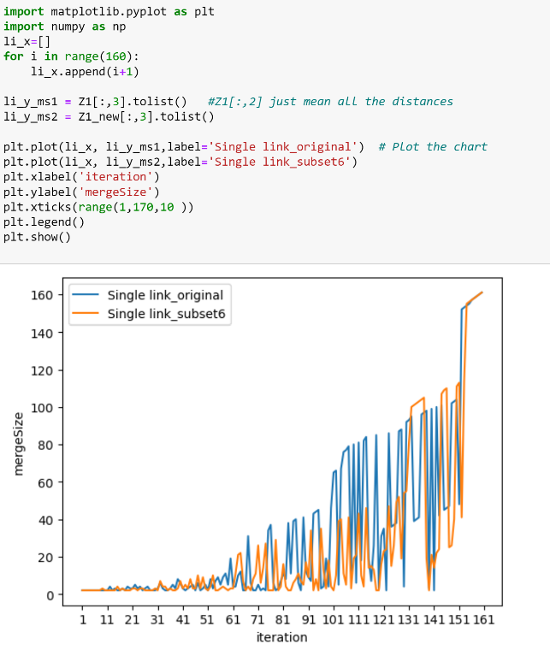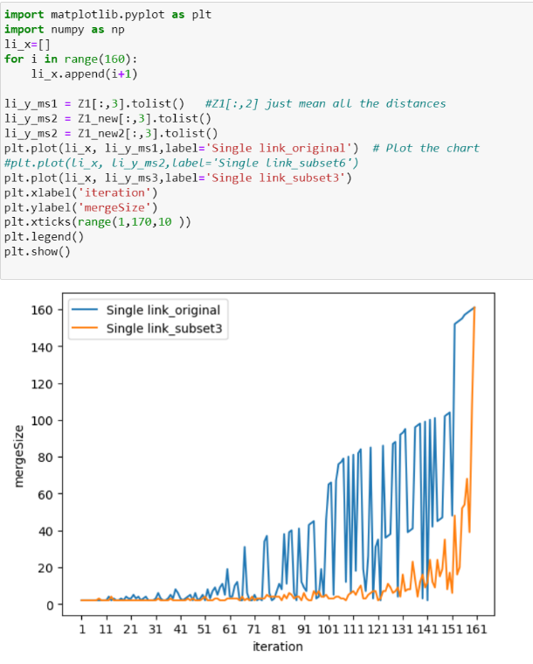

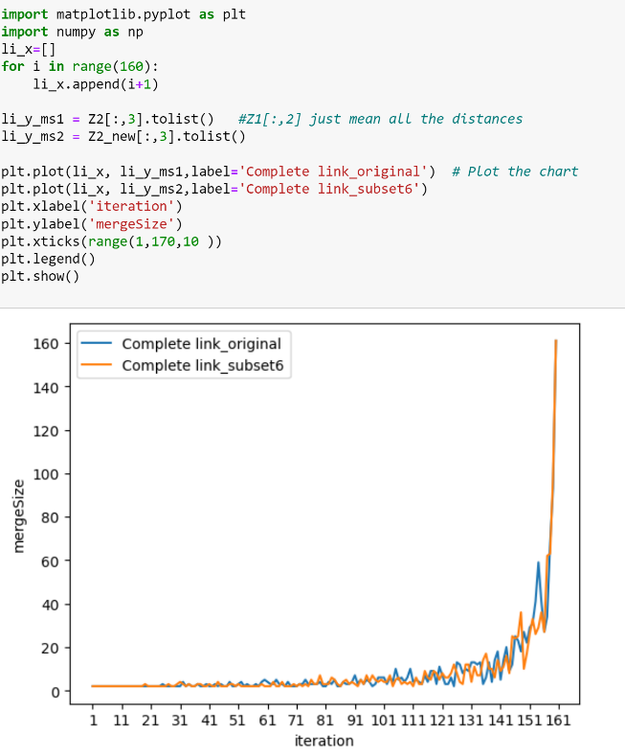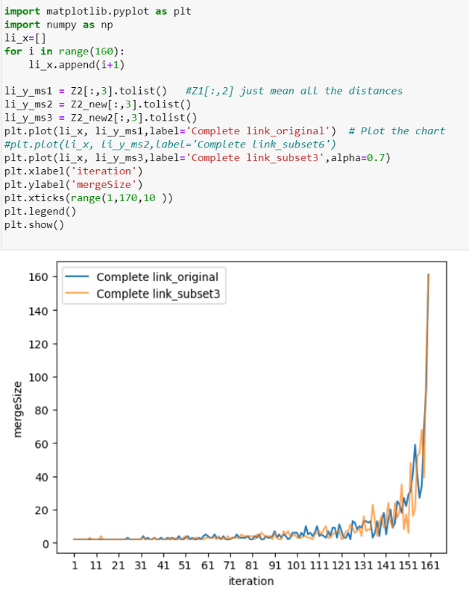

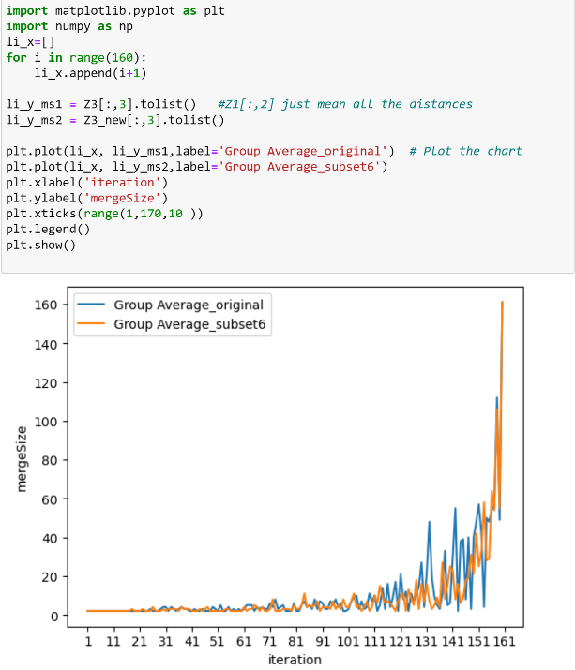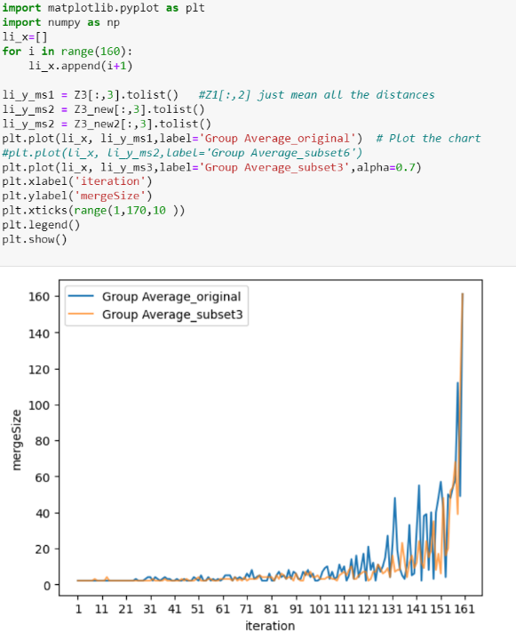

From the graph obtained, we can see that by using the subset of attributes, the line for the merge size **is less fluctuated.** It means that by extracting subset of attributes, the distances among all the records can be reduced, and each point is more likely to find a suitable cluster in early iteration. This avoids merging between a very big cluster and a small one. We are less likely to be merging cluster that shouldn’t be merged. The cluster solution can therefore be improved.

We can further investigate all the merge sizes for the 160 iterations:

We would consider Single Link (Full Attributes) and Single Link (6 Attributes) in following case study.

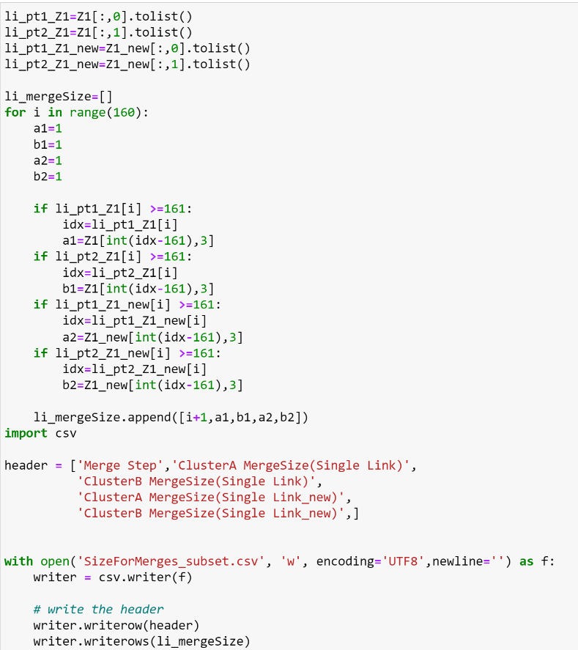

The result are displayed as follows:

Since we have 161 points, Lets define cluster size X as follows:

If X<10, small cluster

If 50>X>=10, medium cluster

If X>=50, large cluster

We would highlight the size with Red, Green and Blue according to the size.

|  |  |  |  |  |
| --- | --- | --- | --- | --- |
| Merge Step | ClusterA MergeSize(Single Link) | ClusterB MergeSize(Single Link) | ClusterA MergeSize(Single Link_new) | ClusterB MergeSize(Single Link_new) |
| 1 | 1 | 1 | 1 | 1 |
| 2 | 1 | 1 | 1 | 1 |
| 3 | 1 | 1 | 1 | 1 |
| 4 | 1 | 1 | 1 | 1 |
| 5 | 1 | 1 | 1 | 1 |
| 6 | 1 | 1 | 1 | 1 |
| 7 | 1 | 1 | 1 | 1 |
| 8 | 1 | 1 | 1 | 1 |
| 9 | 1 | 1 | 1 | 2 |
| 10 | 1 | 1 | 1 | 1 |
| 11 | 1 | 1 | 1 | 1 |
| 12 | 2 | 2 | 1 | 1 |
| 13 | 1 | 1 | 1 | 1 |
| 14 | 1 | 2 | 1 | 1 |
| 15 | 1 | 1 | 1 | 3 |
| 16 | 1 | 1 | 1 | 1 |
| 17 | 1 | 2 | 1 | 2 |
| 18 | 1 | 1 | 1 | 1 |
| 19 | 1 | 3 | 1 | 1 |
| 20 | 1 | 2 | 1 | 1 |
| 21 | 1 | 2 | 1 | 2 |
| 22 | 1 | 4 | 1 | 2 |
| 23 | 1 | 2 | 1 | 1 |
| 24 | 1 | 3 | 1 | 2 |
| 25 | 1 | 1 | 1 | 2 |
| 26 | 1 | 2 | 1 | 1 |
| 27 | 1 | 3 | 1 | 1 |
| 28 | 1 | 1 | 1 | 1 |
| 29 | 1 | 1 | 1 | 1 |
| 30 | 1 | 1 | 1 | 2 |
| 31 | 1 | 2 | 1 | 1 |
| 32 | 2 | 4 | 4 | 3 |
| 33 | 1 | 2 | 2 | 2 |
| 34 | 1 | 1 | 1 | 3 |
| 35 | 1 | 1 | 1 | 1 |
| 36 | 1 | 2 | 1 | 2 |
| 37 | 1 | 4 | 1 | 1 |
| 38 | 1 | 2 | 1 | 1 |
| 39 | 5 | 3 | 1 | 2 |
| 40 | 3 | 3 | 4 | 3 |
| 41 | 1 | 2 | 1 | 2 |
| 42 | 1 | 1 | 1 | 4 |
| 43 | 1 | 2 | 1 | 2 |
| 44 | 1 | 3 | 5 | 3 |
| 45 | 2 | 3 | 1 | 2 |
| 46 | 1 | 1 | 1 | 2 |
| 47 | 1 | 5 | 2 | 8 |
| 48 | 1 | 1 | 1 | 2 |
| 49 | 1 | 2 | 2 | 7 |
| 50 | 2 | 3 | 1 | 2 |
| 51 | 1 | 1 | 1 | 1 |
| 52 | 6 | 2 | 1 | 3 |
| 53 | 1 | 2 | 1 | 9 |
| 54 | 1 | 6 | 1 | 1 |
| 55 | 1 | 8 | 1 | 1 |
| 56 | 1 | 4 | 1 | 2 |
| 57 | 2 | 7 | 1 | 3 |
| 58 | 6 | 5 | 1 | 2 |
| 59 | 1 | 4 | 1 | 1 |
| 60 | 8 | 11 | 1 | 2 |
| 61 | 1 | 3 | 1 | 2 |
| 62 | 1 | 3 | 1 | 10 |
| 63 | 1 | 9 | 10 | 11 |
| 64 | 2 | 10 | 1 | 21 |
| 65 | 1 | 1 | 4 | 3 |
| 66 | 1 | 1 | 1 | 1 |
| 67 | 19 | 12 | 1 | 3 |
| 68 | 3 | 3 | 1 | 1 |
| 69 | 1 | 1 | 1 | 7 |
| 70 | 1 | 1 | 3 | 8 |
| 71 | 1 | 4 | 22 | 4 |
| 72 | 1 | 1 | 3 | 3 |
| 73 | 1 | 2 | 3 | 11 |
| 74 | 1 | 1 | 1 | 26 |
| 75 | 3 | 31 | 1 | 1 |
| 76 | 3 | 34 | 1 | 1 |
| 77 | 1 | 5 | 1 | 1 |
| 78 | 1 | 1 | 2 | 27 |
| 79 | 1 | 2 | 1 | 1 |
| 80 | 1 | 6 | 1 | 3 |
| 81 | 9 | 2 | 14 | 2 |
| 82 | 1 | 7 | 2 | 2 |
| 83 | 1 | 37 | 1 | 1 |
| 84 | 3 | 8 | 1 | 1 |
| 85 | 1 | 38 | 3 | 3 |
| 86 | 1 | 39 | 2 | 6 |
| 87 | 1 | 5 | 7 | 4 |
| 88 | 1 | 1 | 1 | 6 |
| 89 | 1 | 40 | 1 | 4 |
| 90 | 1 | 11 | 1 | 16 |
| 91 | 5 | 4 | 1 | 8 |
| 92 | 1 | 6 | 29 | 5 |
| 93 | 2 | 41 | 1 | 1 |
| 94 | 1 | 43 | 1 | 7 |
| 95 | 1 | 44 | 1 | 1 |
| 96 | 1 | 2 | 1 | 34 |
| 97 | 2 | 2 | 11 | 2 |
| 98 | 12 | 7 | 1 | 2 |
| 99 | 1 | 3 | 1 | 17 |
| 100 | 1 | 45 | 1 | 3 |
| 101 | 19 | 46 | 1 | 1 |
| 102 | 1 | 65 | 1 | 9 |
| 103 | 1 | 4 | 4 | 35 |
| 104 | 1 | 66 | 1 | 39 |
| 105 | 9 | 67 | 1 | 10 |
| 106 | 1 | 76 | 1 | 4 |
| 107 | 2 | 77 | 1 | 40 |
| 108 | 1 | 11 | 1 | 2 |
| 109 | 1 | 79 | 1 | 18 |
| 110 | 1 | 5 | 2 | 19 |
| 111 | 1 | 80 | 2 | 41 |
| 112 | 12 | 6 | 2 | 8 |
| 113 | 1 | 81 | 1 | 3 |
| 114 | 2 | 82 | 3 | 43 |
| 115 | 1 | 18 | 1 | 13 |
| 116 | 1 | 6 | 5 | 10 |
| 117 | 19 | 7 | 2 | 11 |
| 118 | 1 | 84 | 1 | 1 |
| 119 | 1 | 2 | 1 | 1 |
| 120 | 5 | 26 | 1 | 15 |
| 121 | 4 | 31 | 2 | 21 |
| 122 | 1 | 1 | 1 | 23 |
| 123 | 1 | 85 | 1 | 46 |
| 124 | 1 | 35 | 1 | 14 |
| 125 | 1 | 36 | 2 | 24 |
| 126 | 1 | 37 | 2 | 47 |
| 127 | 1 | 86 | 3 | 49 |
| 128 | 1 | 87 | 3 | 16 |
| 129 | 1 | 3 | 2 | 52 |
| 130 | 88 | 4 | 1 | 54 |
| 131 | 1 | 92 | 26 | 55 |
| 132 | 2 | 93 | 19 | 81 |
| 133 | 1 | 38 | 1 | 100 |
| 134 | 1 | 39 | 1 | 101 |
| 135 | 1 | 40 | 1 | 102 |
| 136 | 1 | 95 | 1 | 103 |
| 137 | 1 | 96 | 1 | 104 |
| 138 | 1 | 97 | 4 | 15 |
| 139 | 1 | 2 | 1 | 1 |
| 140 | 1 | 98 | 2 | 19 |
| 141 | 1 | 1 | 1 | 13 |
| 142 | 1 | 99 | 1 | 21 |
| 143 | 1 | 41 | 2 | 22 |
| 144 | 1 | 100 | 2 | 105 |
| 145 | 3 | 42 | 2 | 107 |
| 146 | 1 | 45 | 1 | 109 |
| 147 | 1 | 46 | 1 | 24 |
| 148 | 1 | 101 | 1 | 25 |
| 149 | 1 | 102 | 14 | 26 |
| 150 | 1 | 103 | 1 | 110 |
| 151 | 1 | 47 | 2 | 111 |
| 152 | 104 | 48 | 1 | 40 |
| 153 | 1 | 152 | 1 | 113 |
| 154 | 1 | 153 | 41 | 114 |
| 155 | 1 | 154 | 1 | 155 |
| 156 | 2 | 155 | 1 | 156 |
| 157 | 1 | 157 | 1 | 157 |
| 158 | 1 | 158 | 1 | 158 |
| 159 | 1 | 159 | 1 | 159 |
| 160 | 1 | 160 | 1 | 160 |
| # large clusters | 34 | | 22 | |
| # medium clusters | 37 | | 48 | |
| # small clusters | 249 | | 250 | |

We can see that the cluster process provided by the subset of attributes are much smoother compared to the original one. In the original single link hierarchical clustering, there are more large cluster being merged with smaller clusters. This can be illustrated through the red highlighted cells starting from iteration 102. At this stage, the same algorithm using subset attributes is still merging on medium size cluster with smaller size cluster. This shows that when using subset of attributes, we can obtain smaller distance among all the points, therefore it would **slower the formation of very large-sized cluster in early iterations.**

To further validate this claim, we can also check the solution for k=80 under single link hierarchical clustering using subset of 3 attributes and subset of 6 attributes:

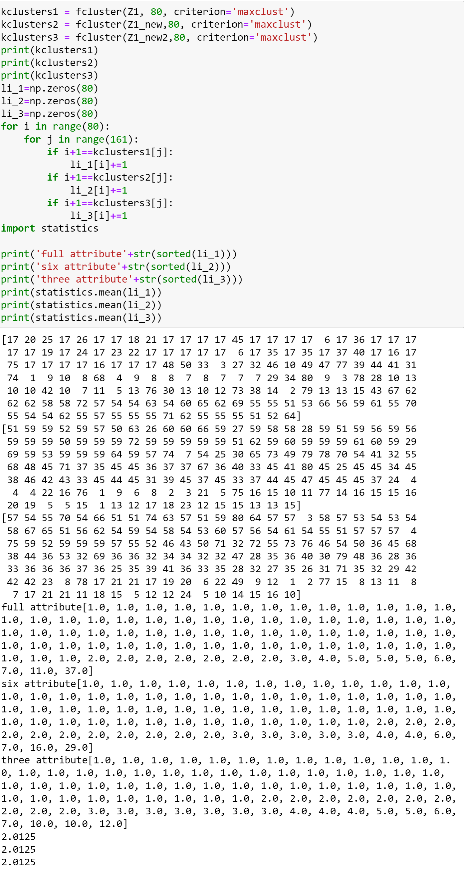

We can see that by using subset of attributes, the number of points within every cluster would be more similar to each other. In order words, the **variance (dispersion) in the distribution of number of points is reduced**. From the last image, we can see that by setting k=80, the maximum number of points within one cluster is 37 when using full set of attributes. This number drops to 29 when we are using 6 attributes. It further drops to 12 when we are using 3 attributes. It means that **if we apply single link hierarchical clustering, we can avoid having very large clusters formed when choosing subset of attributes**. The rate of large cluster formation is reduced.

In the following, we would investigate about how taking subset of attributes would affect the merge size when using Complete Link and Group Average.

Complete Link

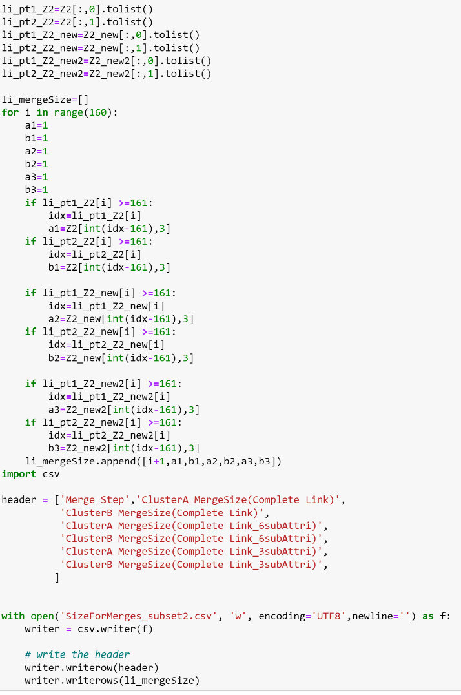

The results are shown as below:

Similar as before, we would define cluster size X as follows:

If X<10, small cluster

If 50>X>=10, medium cluster

If X>=50, large cluster

|  |  |  |  |  |  |  |
| --- | --- | --- | --- | --- | --- | --- |
| Merge Step | ClusterA MergeSize(Complete Link) | ClusterB MergeSize(Complete Link) | ClusterA MergeSize(Complete Link_6subAttri) | ClusterB MergeSize(Complete Link_6subAttri) | ClusterA MergeSize(Complete Link_3subAttri) | ClusterB MergeSize(Complete Link_3subAttri) |
| 1 | 1 | 1 | 1 | 1 | 1 | 1 |
| 2 | 1 | 1 | 1 | 1 | 1 | 1 |
| 3 | 1 | 1 | 1 | 1 | 1 | 1 |
| 4 | 1 | 1 | 1 | 1 | 1 | 1 |
| 5 | 1 | 1 | 1 | 1 | 1 | 1 |
| 6 | 1 | 1 | 1 | 1 | 1 | 1 |
| 7 | 1 | 1 | 1 | 1 | 1 | 1 |
| 8 | 1 | 1 | 1 | 1 | 1 | 2 |
| 9 | 1 | 1 | 1 | 1 | 1 | 1 |
| 10 | 1 | 1 | 1 | 1 | 1 | 1 |
| 11 | 1 | 1 | 1 | 1 | 1 | 1 |
| 12 | 1 | 1 | 1 | 1 | 1 | 1 |
| 13 | 1 | 1 | 1 | 1 | 1 | 3 |
| 14 | 1 | 1 | 1 | 1 | 1 | 1 |
| 15 | 1 | 1 | 1 | 1 | 1 | 1 |
| 16 | 1 | 1 | 1 | 1 | 1 | 1 |
| 17 | 1 | 1 | 1 | 1 | 1 | 1 |
| 18 | 1 | 1 | 1 | 1 | 1 | 1 |
| 19 | 1 | 1 | 1 | 2 | 1 | 1 |
| 20 | 1 | 1 | 1 | 1 | 1 | 1 |
| 21 | 1 | 1 | 1 | 1 | 1 | 1 |
| 22 | 1 | 1 | 1 | 1 | 1 | 1 |
| 23 | 1 | 1 | 1 | 1 | 1 | 1 |
| 24 | 1 | 1 | 1 | 1 | 1 | 1 |
| 25 | 1 | 2 | 1 | 1 | 1 | 1 |
| 26 | 1 | 1 | 1 | 1 | 1 | 1 |
| 27 | 1 | 1 | 1 | 2 | 1 | 1 |
| 28 | 1 | 1 | 1 | 1 | 1 | 1 |
| 29 | 1 | 1 | 1 | 1 | 1 | 1 |
| 30 | 1 | 1 | 1 | 2 | 1 | 1 |
| 31 | 1 | 1 | 1 | 3 | 1 | 1 |
| 32 | 2 | 2 | 1 | 2 | 1 | 2 |
| 33 | 1 | 1 | 1 | 1 | 1 | 1 |
| 34 | 1 | 2 | 1 | 2 | 1 | 1 |
| 35 | 1 | 1 | 1 | 1 | 1 | 1 |
| 36 | 1 | 1 | 1 | 1 | 1 | 1 |
| 37 | 1 | 2 | 1 | 2 | 1 | 2 |
| 38 | 1 | 1 | 1 | 2 | 1 | 1 |
| 39 | 1 | 1 | 1 | 1 | 1 | 1 |
| 40 | 1 | 2 | 1 | 1 | 1 | 1 |
| 41 | 1 | 1 | 1 | 2 | 1 | 1 |
| 42 | 1 | 1 | 1 | 1 | 1 | 1 |
| 43 | 1 | 2 | 1 | 1 | 1 | 1 |
| 44 | 1 | 1 | 2 | 2 | 1 | 2 |
| 45 | 1 | 2 | 1 | 1 | 1 | 1 |
| 46 | 1 | 1 | 1 | 1 | 1 | 2 |
| 47 | 1 | 1 | 1 | 1 | 1 | 1 |
| 48 | 2 | 2 | 1 | 2 | 1 | 1 |
| 49 | 1 | 1 | 1 | 2 | 1 | 1 |
| 50 | 1 | 1 | 1 | 1 | 1 | 2 |
| 51 | 1 | 2 | 1 | 2 | 2 | 2 |
| 52 | 2 | 2 | 1 | 1 | 1 | 1 |
| 53 | 1 | 1 | 1 | 1 | 1 | 1 |
| 54 | 1 | 2 | 1 | 1 | 1 | 1 |
| 55 | 1 | 1 | 1 | 1 | 1 | 2 |
| 56 | 1 | 1 | 1 | 1 | 1 | 2 |
| 57 | 1 | 2 | 1 | 1 | 1 | 1 |
| 58 | 1 | 1 | 1 | 1 | 1 | 1 |
| 59 | 2 | 2 | 1 | 2 | 1 | 1 |
| 60 | 1 | 4 | 1 | 1 | 1 | 2 |
| 61 | 1 | 3 | 1 | 1 | 1 | 2 |
| 62 | 1 | 2 | 1 | 1 | 1 | 2 |
| 63 | 1 | 2 | 2 | 2 | 1 | 2 |
| 64 | 2 | 3 | 1 | 1 | 1 | 2 |
| 65 | 1 | 2 | 1 | 1 | 1 | 1 |
| 66 | 1 | 2 | 2 | 2 | 2 | 2 |
| 67 | 1 | 1 | 1 | 1 | 1 | 1 |
| 68 | 1 | 3 | 1 | 1 | 1 | 2 |
| 69 | 1 | 1 | 1 | 1 | 1 | 1 |
| 70 | 1 | 1 | 1 | 2 | 2 | 2 |
| 71 | 1 | 1 | 1 | 1 | 1 | 1 |
| 72 | 1 | 2 | 1 | 2 | 1 | 2 |
| 73 | 1 | 2 | 1 | 1 | 1 | 2 |
| 74 | 1 | 4 | 1 | 2 | 1 | 2 |
| 75 | 1 | 2 | 1 | 1 | 1 | 2 |
| 76 | 1 | 2 | 2 | 3 | 3 | 2 |
| 77 | 1 | 2 | 1 | 2 | 1 | 3 |
| 78 | 1 | 2 | 1 | 2 | 2 | 2 |
| 79 | 2 | 2 | 3 | 4 | 2 | 2 |
| 80 | 1 | 1 | 1 | 2 | 2 | 2 |
| 81 | 1 | 1 | 1 | 2 | 1 | 3 |
| 82 | 1 | 3 | 1 | 2 | 1 | 1 |
| 83 | 1 | 2 | 3 | 3 | 1 | 4 |
| 84 | 2 | 3 | 2 | 3 | 1 | 2 |
| 85 | 1 | 1 | 1 | 2 | 2 | 4 |
| 86 | 1 | 1 | 1 | 1 | 2 | 3 |
| 87 | 1 | 3 | 1 | 3 | 1 | 2 |
| 88 | 1 | 2 | 1 | 4 | 1 | 3 |
| 89 | 1 | 2 | 1 | 2 | 2 | 2 |
| 90 | 1 | 3 | 1 | 3 | 1 | 1 |
| 91 | 3 | 4 | 1 | 2 | 2 | 4 |
| 92 | 1 | 2 | 1 | 1 | 1 | 2 |
| 93 | 2 | 3 | 2 | 3 | 1 | 1 |
| 94 | 1 | 2 | 1 | 2 | 1 | 1 |
| 95 | 2 | 3 | 4 | 3 | 4 | 3 |
| 96 | 1 | 3 | 2 | 2 | 3 | 2 |
| 97 | 1 | 1 | 1 | 6 | 3 | 4 |
| 98 | 1 | 2 | 3 | 2 | 1 | 3 |
| 99 | 4 | 2 | 2 | 2 | 1 | 3 |
| 100 | 2 | 4 | 1 | 4 | 1 | 4 |
| 101 | 3 | 3 | 1 | 3 | 1 | 2 |
| 102 | 1 | 2 | 2 | 2 | 1 | 2 |
| 103 | 1 | 5 | 2 | 5 | 1 | 2 |
| 104 | 1 | 3 | 1 | 1 | 2 | 2 |
| 105 | 5 | 5 | 2 | 3 | 1 | 3 |
| 106 | 2 | 3 | 3 | 3 | 1 | 2 |
| 107 | 2 | 4 | 1 | 2 | 1 | 2 |
| 108 | 1 | 3 | 1 | 3 | 1 | 1 |
| 109 | 2 | 4 | 1 | 2 | 3 | 2 |
| 110 | 4 | 6 | 2 | 2 | 1 | 5 |
| 111 | 1 | 3 | 1 | 1 | 3 | 4 |
| 112 | 1 | 4 | 3 | 3 | 2 | 3 |
| 113 | 1 | 3 | 1 | 2 | 3 | 5 |
| 114 | 1 | 2 | 1 | 2 | 3 | 7 |
| 115 | 2 | 5 | 2 | 7 | 1 | 2 |
| 116 | 2 | 2 | 2 | 4 | 1 | 2 |
| 117 | 3 | 6 | 2 | 3 | 1 | 4 |
| 118 | 5 | 4 | 5 | 4 | 4 | 2 |
| 119 | 1 | 2 | 3 | 5 | 2 | 5 |
| 120 | 4 | 7 | 2 | 3 | 2 | 5 |
| 121 | 3 | 4 | 5 | 3 | 1 | 1 |
| 122 | 1 | 2 | 1 | 5 | 1 | 2 |
| 123 | 1 | 2 | 2 | 4 | 3 | 4 |
| 124 | 1 | 5 | 4 | 4 | 4 | 3 |
| 125 | 1 | 1 | 5 | 7 | 4 | 7 |
| 126 | 2 | 11 | 2 | 6 | 3 | 6 |
| 127 | 7 | 5 | 1 | 3 | 3 | 3 |
| 128 | 2 | 6 | 1 | 2 | 4 | 3 |
| 129 | 6 | 4 | 3 | 9 | 3 | 6 |
| 130 | 3 | 6 | 3 | 9 | 2 | 2 |
| 131 | 10 | 3 | 2 | 2 | 6 | 10 |
| 132 | 3 | 10 | 5 | 6 | 4 | 3 |
| 133 | 3 | 9 | 1 | 6 | 1 | 7 |
| 134 | 4 | 9 | 4 | 3 | 1 | 7 |
| 135 | 1 | 2 | 2 | 12 | 7 | 16 |
| 136 | 3 | 3 | 5 | 12 | 5 | 8 |
| 137 | 5 | 8 | 3 | 7 | 1 | 3 |
| 138 | 1 | 3 | 7 | 3 | 5 | 7 |
| 139 | 4 | 10 | 4 | 2 | 7 | 9 |
| 140 | 6 | 12 | 6 | 8 | 2 | 7 |
| 141 | 1 | 4 | 5 | 4 | 5 | 7 |
| 142 | 1 | 13 | 4 | 7 | 8 | 16 |
| 143 | 7 | 13 | 8 | 8 | 3 | 9 |
| 144 | 3 | 6 | 2 | 6 | 3 | 6 |
| 145 | 3 | 9 | 8 | 17 | 11 | 13 |
| 146 | 13 | 12 | 14 | 10 | 6 | 9 |
| 147 | 3 | 20 | 11 | 14 | 4 | 15 |
| 148 | 4 | 14 | 12 | 24 | 23 | 12 |
| 149 | 2 | 25 | 3 | 7 | 5 | 3 |
| 150 | 13 | 9 | 6 | 11 | 8 | 9 |
| 151 | 6 | 23 | 16 | 10 | 2 | 4 |
| 152 | 13 | 18 | 8 | 25 | 24 | 24 |
| 153 | 14 | 27 | 9 | 17 | 4 | 12 |
| 154 | 18 | 41 | 4 | 25 | 12 | 8 |
| 155 | 12 | 29 | 10 | 26 | 35 | 17 |
| 156 | 5 | 22 | 1 | 26 | 6 | 48 |
| 157 | 3 | 31 | 33 | 29 | 16 | 52 |
| 158 | 41 | 27 | 36 | 27 | 19 | 20 |
| 159 | 59 | 34 | 36 | 62 | 68 | 39 |
| 160 | 68 | 93 | 63 | 98 | 54 | 107 |
| #of large clusters | 3 | | 3 | | 4 | |
| #of medium clusters | 27 | | 23 | | 19 | |
| #of small clusters | 290 | | 294 | | 297 | |

The merge size of the clusters constructed using subset of attributes are pretty similar to the original one. The only difference we can locate is that by taking a smaller subset of attributes, the number of small clusters formed would be greater. This implies that we would have more smaller size clusters before we do the large-size-cluster merging. This make sense as taking useful subset of attributes just mean that the distance between records can be reduced. As a result, one point may have greater opportunity in locating a suitable cluster, which avoids it merging into the cluster it doesn’t belong to. The size of each cluster can therefore be more evenly distributed.

For group average method, it is believed that the situation is similar. There would not be a very significant difference. But in general, the merge size would be smaller for the same reason.